

**Food and Agriculture Organization of the United Nations**

**Yemen**

Plan of Action

2018-2020

Strengthening resilient agricultural livelihoods

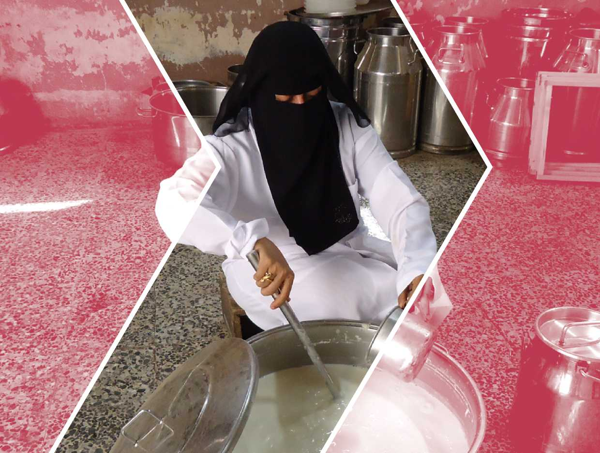

**Yemen**

Plan of Action

2018-2020

Strengthening resilient agricultural livelihoods

Food and Agriculture Organization of the United Nations Rome, 2018

RECOMMENDED CITATION

**FAO**. 2018. *Yemen, Plan of Action -Strengthening resilient agricultural livelihoods (2018-2020).* Rome. 60 pp.

The designations employed and the presentation of material in this information product do not imply the expression of any opinion whatsoever on the part of the Food and Agriculture Organization of the United Nations (FAO) concerning the legal or development status of any country, territory, city or area or of its authorities, or concerning the delimitation of its frontiers or boundaries. The mention of specific companies or products of manufacturers, whether or not these have been patented, does not imply that these have been endorsed or recommended by FAO in preference to others of a similar nature that are not mentioned.

The views expressed in this information product are those of the author(s) and do not necessarily reflect the views or policies of FAO.

© FAO, 2018

FAO encourages the use, reproduction and dissemination of material in this information product. Except where otherwise indicated, material may be copied, downloaded and printed for private study, research and teaching purposes, or for use in non-commercial products or services, provided that appropriate acknowledgement of FAO as the source and copyright holder is given and that FAO’s endorsement of users’ views, products or services is not implied in any way.

All requests for translation and adaptation rights, and for resale and other commercial use rights should be made via [www.fao.org/contact-us/licence-request](http://www.fao.org/contact-us/licence-request) or addressed to [copyright@fao.org](mailto:copyright@fao.org).

FAO information products are available on the FAO website ([www.fao.org/publications](http://www.fao.org/publications)) and can be purchased through [publications-sales@fao.org](mailto:publications-sales@fao.org).

Contents

Acronyms and abbreviations iv

Executive summary 1

Introduction 4

Relevance 7

General context 7

Humanitarian context 7

Key facts 8

Agriculture and food security context 8

Justification 11

Alignment and strategic fit 11

Lessons learned 12

Stakeholder engagement 13

Framework 15

Goal and objectives 15

Strategic approach 15

Targeting criteria 16

Gender equality 17

Conflict sensitivity and contribution to sustaining peace 18

Pillars and key intervention areas 21

Cost estimate 46

FAO’s comparative advantage 48

Mandate to act 48

Capacity to act 48

Position to act 50

Implementation arrangements 51

Institutional framework 51

Coordination 52

Strategic partnerships 53

Monitoring and reporting 53

Communication and outreach 55

Community animal health worker

Acronyms and **CAHW**

abbreviations **CCA**

**CSA**

**DRR**

**ELRP**

**FAO**

**FBS**

**FFS**

**FPMIS**

**FSAC**

**FsFS**

**FSIS**

**GDP**

**IDP**

**ILO**

**IPC**

**LFFS**

**MAI**

**MFW**

**MoPIC**

**MWE**

**NRM**

**OCHA**

**PHM**

Climate change adaptation

Climate-smart agriculture

Disaster risk reduction

Emergency Livelihood Response Plan

Food and Agriculture Organization of the United Nations

Farmer/fisher business school

Farmer field school

Field Programme Management Information System

Food Security and Agriculture Cluster

Fisher field school

Food security and nutrition information system

Gross domestic product

Internally displaced person

International Labour Organization

Integrated Food Security Phase Classification

Livestock farmer field school

Ministry of Agriculture and Irrigation

Ministry of Fish Wealth

Ministry of Planning and International Cooperation

Ministry of Water and Environment

Natural resources management

United Nations Office for the Coordination of

Humanitarian Affairs

Post-harvest management

|  |  |
| --- | --- |
| **PPCP** | Public-private-community partnership |
| **RNE** | Regional Office for the Near East and North Africa |
| **SDG** | Sustainable Development Goal |
| **TAD** | Transboundary animal disease |
| **UN** | United Nations |
| **UNDP** | United Nations Development Programme |
| **UNICEF** | United Nations Children Fund |
| **USAID** | United States Agency for International Development |
| **WFP** | World Food Programme |
| **WUA** | Water users’ association |

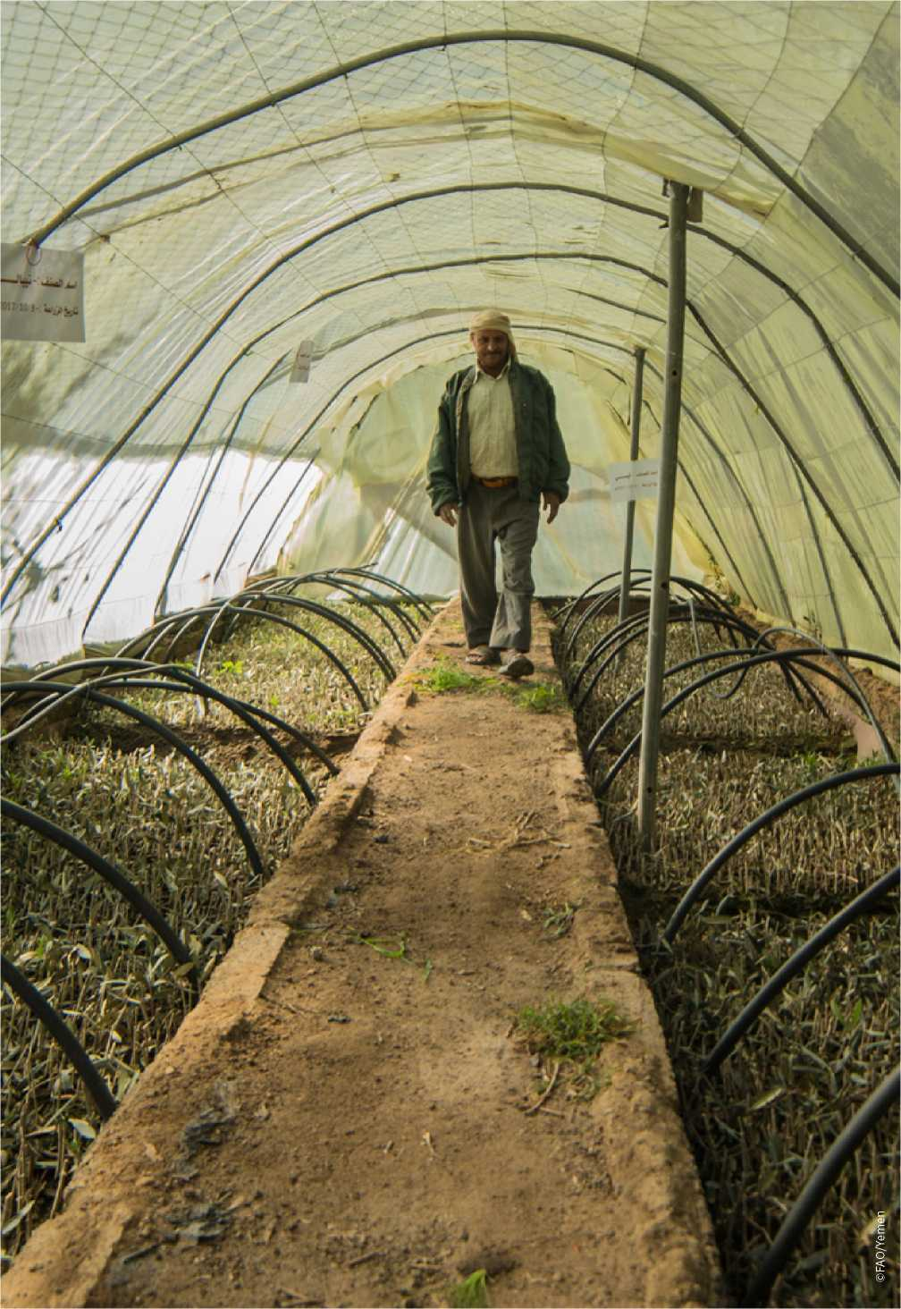

|  |  |
| --- | --- |
| Executive | As Yemen enters its fourth year, conflict, severe economic decline |
| summary | and collapsing essential services have taken an enormous toll on the population, exacerbating existing vulnerabilities. The United Nations (UN) has declared the last three years of the crisis as a system-wide Level 3 humanitarian emergency. Level 3 responses are activated in the most complex and challenging humanitarian emergencies, when the highest level of mobilization is required across the humanitarian system. Even before the conflict escalated, the country suffered high levels of poverty, food insecurity, undernutrition and malnutrition, water shortages and land degradation. Yemenis are also facing armed conflict, displacement, risk of famine and disease outbreaks. |
| Yemen is experiencing the world’s largest food security crisis | Since 2015, the Food and Agriculture Organization of the United Nations’ (FAO’s) support in Yemen has included providing key agricultural inputs, cash-based transfers and training, which has contributed to more than 2 million resource-poor households improving their food security and nutrition and strengthened their ability to cope with crises.  In addition to short-term activities under UN-led humanitarian response plans, longer-term interventions are required to achieve lasting impact on food security and nutrition. FAO’s Plan of Action - Strengthening resilient agricultural livelihoods (2018-2020) serves as a strategic planning tool to guide FAO operations in Yemen through food security, nutrition and agricultural livelihoods programmes and projects. This document will also inform planning and programming for emergency and recovery support to Yemen’s agriculture sector. |
| While restoring Yemen’s agriculture sector, FAO aims to improve the food security and nutrition of vulnerable families and strengthen their resilience | The overall goal of the three-year Plan of Action is to make a significant contribution towards improving food security and nutrition and strengthening the resilience of vulnerable rural and peri-urban households while restoring the agriculture sector of the country. As a dynamic document, the Plan ofAction will be implemented through a flexible twin-track approach that can be tailored to its target areas for different types of intervention based on the conflict dynamics and changing circumstances in the country over the next three years. Strategic decisions on targeting will be informed by conflict analysis and regular conflict monitoring that ensures conflict-sensitive interventions.  The twin-track strategic approach will focus on:   * Scaling up current emergency food security, nutrition and cropping, pastoral and fisheries-based livelihood responses across all famine-risk districts. * Investing in capacity development and improved agricultural service delivery interventions at the governorate, district and community levels in order to recover and improve crop, livestock and fisheries productivity on a sustainable basis, as well as promoting sustainable natural resources management, taking into account the specific needs and priorities of women and girls. |

* Strengthening sectoral planning, programming, implementation and coordination mechanisms for the efficient utilisation of resources along and across both tracks and a more cost-effective impact on longer- term household and community resilience.

The Plan of Action is estimated at a total cost of USD 228.5 million for the period 2018 to 2020 to improve the food security and nutrition of 1.3 million households (9.66 million people). It comprises three pillars, which mutually reinforce 21 short- and longer-term key intervention areas in support of safeguarding, protecting and restoring Yemen’s agriculture sector in target areas.

Estimated at

USD 228.5 million for the period 2018 to 2020, FAO’s Plan of Action aims to improve the food security and nutrition of 9.66 million people

Pillar 1. Emergency support to the most vulnerable rural and peri-urban households (across famine-risk districts)

* Eight key intervention areas covering cash-based transfers, crop, livestock and fisheries production, value addition and income generation, surveillance and control of transboundary plant and animal pests and diseases and desert locust management.
* Targeting 1.17 million households.
* Estimated at USD 150 million.

Pillar 2. Support to the sustainable restoration and diversification of agricultural livelihoods[1] and agri-food systems (across districts where access is secured)

* Nine key intervention areas covering post-damage needs assessments, rehabilitation of agricultural facilities, seed-supply systems, agricultural extension and animal production and health services, sustainable land and water management and climate-smart agriculture, livestock feeding systems, post-harvest management and value chain development, quality control of agricultural imports and exports and food safety and diversification of fisheries livelihoods.
* Targeting 135 200 households.
* Estimated at USD 70.5 million.

Pillar 3. Improved coordination of planning, programming and support for food security, nutrition and agricultural livelihoods

* Four key intervention areas covering the establishment/strengthening of government networks, information and early warning systems, decentralised information platforms and the Food Security and Agriculture Cluster.
* Estimated cost of USD 8 million.

Yemen is experiencing the world’s largest food security crisis. As it enters

£ | usujsa

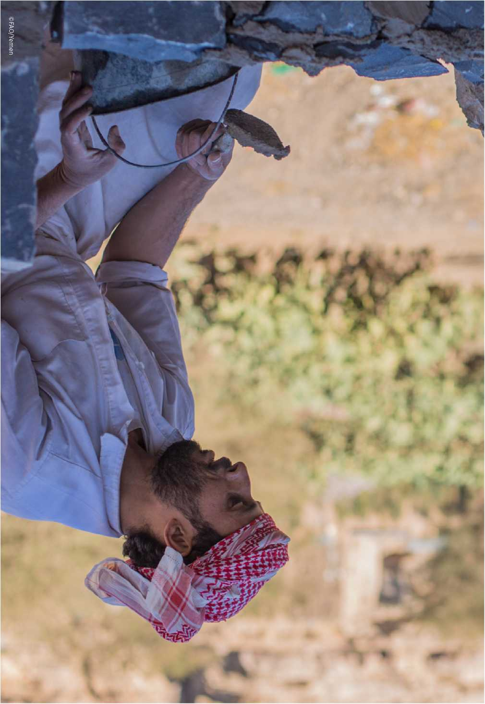

Introduction

75 percent of the country’s population (22.2 million people) are in need of humanitarian assistance

This Plan of Action will guide FAO operations in Yemen through food security, nutrition and agricultural livelihoods programmes and projects

its fourth year, conflict, severe economic decline and collapsing essential services have taken an enormous toll on the population, exacerbating existing vulnerabilities. The United Nations (UN) has declared the last three years of the crisis as a system-wide Level 3 humanitarian emergency. Level 3 responses are activated in the most complex and challenging humanitarian emergencies, when the highest level of mobilization is required across the humanitarian system. Even before the conflict escalated, the country suffered high levels of poverty, food insecurity, undernutrition and malnutrition, water shortages and land degradation. Yemenis are also facing armed conflict, displacement, risk of famine and disease outbreaks. Some 75 percent of the country’s total population of 29.3 million (i.e. 22.2 million people) are in need of humanitarian assistance, including 11.3 million people who are in acute need and urgently require immediate assistance to survive - an increase of 1 million since June 2017[2]. Vulnerable populations in 107 out of 333 districts are facing heightened risk of famine and require integrated response efforts to avert a looming catastrophe.

The emergency assistance provided by the Food and Agriculture Organization of the United Nations (FAO) and the Food Security and Agriculture Cluster (FSAC) partners since 2015 has contributed significantly to mitigate people’s needs in Yemen. Without this much-needed assistance, the “people in need” number would have been much higher. FAO’s support in Yemen has included providing key agricultural inputs (e.g. cereal and vegetable seeds, livestock and poultry, animal feed, veterinary supplies and fishing gear), cash-based transfers and training, which has contributed to more than 2 million resource-poor households improving their food security and nutrition and strengthened their ability to cope with crises.

In addition to short-term activities under UN-led humanitarian response plans, longer-term interventions are required to achieve lasting impact on food security and nutrition, and restore and strengthen agricultural livelihoods[3] of vulnerable rural and peri-urban populations in target areas, taking into account the specific needs and priorities of women and girls.[4]

To address these challenges, FAO has prepared the Plan of Action - Strengthening resilient agricultural livelihoods (2018-2020). This Plan will serve as a strategic planning tool to guide FAO operations in Yemen through food security, nutrition and agricultural livelihoods programmes and projects. This document will also inform the planning and programming for emergency and recovery support to Yemen’s agriculture sector by the Government of Yemen and its resource partners through the

Organization’s well-established technical cooperation mechanisms. This will, in turn, strengthen the resilience[5] of affected populations and the capacity of relevant agricultural service providers, making sure to “leave no one behind” in line with the commitments of the 2030 Agenda for Sustainable Development.

The Plan of Action will not only address the damage and losses suffered by families of farmers, pastoralists and fishers as a result of the protracted crisis, but those caused by the increasing frequency of climate-related threats and natural hazards and outbreaks of plant and animal pests and diseases. This document also provides for improved coordination of short- and medium-term advocacy, planning, investment programming and technical support to Yemen’s agriculture sector. This will provide a foundation for the long-term reconstruction and rehabilitation of relevant infrastructure, stakeholder institutional organization and strengthening, and agricultural policy and strategy development in the future.

In this context, FAO’s Plan of Action aims to programme emergency relief and livelihood recovery interventions side by side in order to:

FAO’s Plan of Action aims to programme emergency relief and livelihood recovery interventions side by side

* scale up current emergency food security and agricultural livelihood responses across all affected parts of the country;
* invest in capacity development and agricultural service delivery interventions that will recover and improve crop, livestock and fisheries productivity on a sustainable basis; and
* strengthen sectoral planning, programming, implementation and coordination mechanisms for the efficient utilisation of resources.

The Plan of Action aims to reach an estimated 1.3 million vulnerable rural and peri-urban households (9.66 million people) throughout its three-year duration.

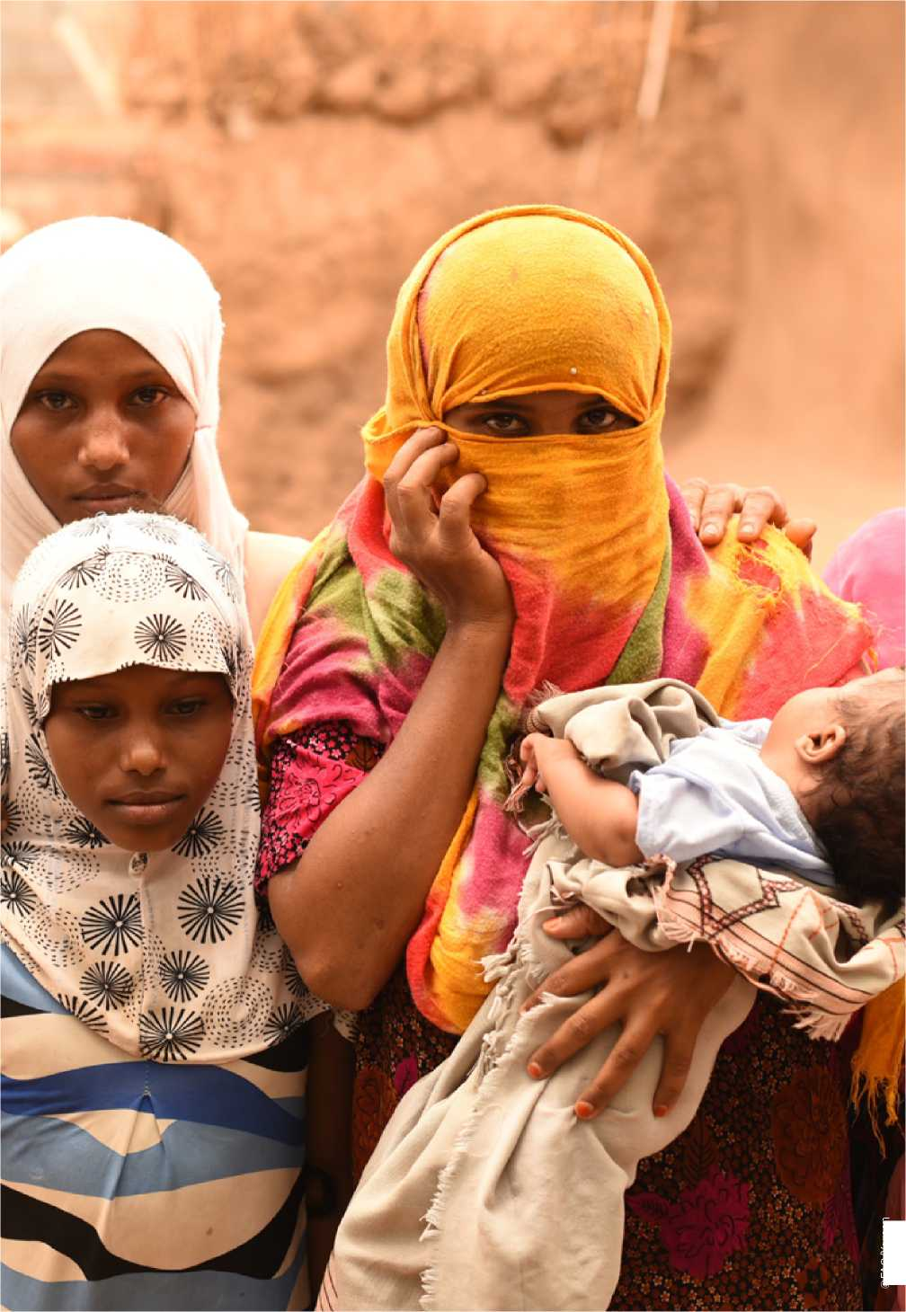

©FAO/Yemen

|  |  |
| --- | --- |
|  | Yemen has been among the poorest countries in the world for decades. Now it has the largest humanitarian situation. Instability, conflict and import/export restrictions have devastated Yemen’s economy. The country’s gross domestic product (GDP) has declined by 41 percent since March 2015 - equivalent to a loss of USD 32 billion (or |
| For decades, Yemen has been among the poorest countries in the world | USD 1 180 per capita). Since 2015, the currency has lost 80 percent of its value - 28 percent alone in 2017. Losses in infrastructure have been estimated at USD 19 billion, bringing massive disruption of services across all sectors.[6]  The continued decline of Yemen’s economy and escalation of conflict have significantly contributed to the recent price hikes of fuel and basic food commodities. In a country that imports 90 percent of its wheat, this has sharply increased commodity prices, making many essential food items out of the reach of its vulnerable population. As a result, 80 percent of Yemenis are now in debt, and more than half of all households have had to buy food on credit. It is estimated that 60 percent of households have resorted to negative coping mechanisms such as reducing their food portions or skipping meals altogether.[7] The ongoing crisis has particularly affected imports, and thus the availability, of essential food items. Import restrictions have also sharply increased fuel prices by more than 150 percent compared with pre-crisis levels, which in turn has dramatically increased transportation costs for essential food commodities and trucked water, and pumping costs of irrigation, which many farmers needed to boost agricultural production.  Instability, conflict and displacement have increased the number of |
| Instability, conflict and displacement have increased the number of women-headed families | women-headed households, exacerbated the gender gap and made it more difficult to collect sex and age disaggregated data - challenging humanitarian actors when ensuring their services, resources and protection measures are accessible to all the population.  Humanitarian context  Yemen’s protracted crisis has had severe negative impacts on the livelihoods of millions of people in the country. The increasing instability continues to threaten the delivery of essential humanitarian services and set back progress in human development achieved in several areas over the recent past. |

Relevance

General context

Key facts

Agriculture and food security context

**75%** of the population lives in rural areas (22 million people)

**M17.8 million**people food insecure, of which **8.4 million** severely food insecure - **24%** increase compared with 2017

**M^107** (out of 333) districts at

risk of famine (compared with 95

districts in 2016)

***2m* 2 million** idps

**1 million** returnees

**1.8 million** children acutely malnourished

Prior to the conflict, agriculture and fisheries contributed

between 18 and 27 percent of Yemen’s GDP, 25 to 30 percent of the annual food requirement and employed more than 50 percent of the country’s workforce. These percentages are now shrinking as the agriculture sector has become one of the worst hit by the current crisis and local food production has been severely compromised. Some of the factors contributing to this, and attributed directly to the crisis, include: (i) limited availability and high cost of agricultural inputs; (ii) low availability and high cost of animal feed; (iii) inability to control plant and animal pests and diseases; (iv) increasing production of *qat (Catha edulis)* as a cash crop, which reduces the amount of land available for food production and contributes to the depletion of the water table; (v) an emigrating workforce; and (vi) limited public resources allocated to the sector. Other more structural factors include: (vii) diminishing natural resources, in particular groundwater mining (following uncontrolled extraction and inefficient water management practices) and the degradation of land (following deforestation, lack of terrace maintenance, soil erosion and soil salinity); (viii) the effects of climate change and variability; and (ix) inequitable access to arable land.

In recent years, Yemen’s rainfall patterns have shown increasing extremes - attributed to climate change and variability. The country suffers from “absolute” water scarcity, with an internal renewable water resources rate of less than 100 m3 per inhabitant per year. Major cities are running out of water and a large number of the population does not have access to safe drinking water (with serious implications for the spread of human and animal diseases, in particular cholera). Frequent droughts and flash floods have affected crop production, livelihoods and income generation for a significant percentage of the population. Many households also face the threat of crop failure due to the effects of pests and diseases, sandstorms and land degradation - all of which further threaten their food security and nutrition.

The main agricultural crops produced in Yemen are: fruits (mango, grape, citrus, banana, papaya and date); vegetables (tomato, potato, water and sweet melon, onion and cucumber); cereals (maize, wheat, sorghum and barley); high value crops (sesame, cotton, tobacco and coffee); and *qat*. Yemen is also one of the countries at risk desert locust attacks and requires regular monitoring, surveillance and timely response and action. The unstable situation in the country and the sharp drop in the Government’s ability to provide financial support for many public services have had dramatic effect on field operations for the monitoring and control of plant pests and diseases such as desert locust and tomato borer, red palm weevil and wheat rust. Attention also needs to be given to fall armyworm, which first surfaced in Africa in 2016. In early 2017 the infestation rate, particularly in Ethiopia, increased dramatically. Fall armyworm spread across the continent throughout 2017, and by the start of 2018, the infestation had spread to millions of hectares of maize and more than 80 other crops, most belonging to smallholder farmers. If



**73%** of the population relied on agriculture for their livelihoods prior to the escalation of violence - this number has declined to **60%** today, of which **85%** require emergency agricultural support

**38%** decrease in cultivated area and crop production since

March 2015

**40-42%** decrease in sheep and goat production since

March 2015

**54%** of farmers face problems in controlling crop and livestock pests and diseases

left unchecked, fall armyworm could drive more than 300 million people in Africa into hunger and lead to economic losses of up to USD 4.8 billion from maize production alone. The insect was recently reported in Sudan, thus increasing the risk of introduction to Yemen. Prevention is key factor to protect the country from this destructive pest.

About 90 percent of Yemen is classed as arid, semi-arid and desert. Even before the crisis, the availability of water for a rapidly growing population was an ever-increasing problem. It is anticipated that groundwater reserves are likely to be mostly depleted within 20 to 30 years, irrespective of climate change, reducing agricultural output by up to 40 percent. Poor sanitation brought about by the crisis is also having an effect on water quality - already at risk from salinisation due to over-extraction and inefficient water management practices. Further detailed water quantity and quality assessments will be required once access is assured to river basin areas.

Livestock are a primary source of income for smallholder farmers under a mixed farming system, particularly sheep, goats, cattle, camels and poultry. The ongoing conflict has decimated livestock herds for many farmers, especially among displaced pastoral and agro-pastoral households. Limited veterinary services, and scarcity and high cost of animal vaccines and drugs, are causing the spread of endemic diseases such as *peste des petits ruminants*, sheep and goat pox, foot and mouth disease and lumpy skin disease. Furthermore, the shortage and soaring prices of animal feed has led to poor livestock productivity with high levels of animal mortality. Also, the industrial poultry sector, the major provider of protein and income to poor people (through chicken meat and eggs), is under serious threat as all vaccines and feed for poultry need to be imported.



Considerable efforts have been made over the years to develop the fisheries subsector. Prior to the crisis the fisheries subsector was Yemen’s second greatest revenue earner after oil. However, it has not been able to absorb a greater proportion of the workforce, due to challenges that have slowed its development and raised sustainability issues. These include limited capacity along all steps of the fisheries value chain, including low productivity, low quality of products, inadequate access to lucrative international markets, unknown environmental carrying capacity of fish stocks, declining stocks, and limited private sector development of the subsector. Furthermore, the situation has worsened following two cyclones in November 2015, while the current conflict has heavily affected fishers due to restricted access to the sea, increased fuel prices, disruption of fish exports, destruction of fishing equipment and inadequate cold storage facilities.

Forests and rangelands have been degraded due to the overcutting of trees and shrubs for construction, fuel and fodder, to the point where they have almost disappeared. The increasing effects of climate change and the concentration of internally displaced people (IDPs) in some locations are expected to further degrade and deplete the natural resources currently available to agriculture.

Less than 1 percent of agricultural landholders in Yemen are female. However, women have a major role in agriculture, providing 60 percent of labour in crop farming, 90 percent in livestock rearing and 10 percent of wage labour. Women-headed households are more at risk of food insecurity due to their limited work opportunities and reduced access to productive resources, services and rural institutions. Moreover, women are generally excluded from economic transactions in the local markets. When food is scarce, women are the first family members to eat less as a coping mechanism, even though they continue to do hard labour (e.g. working in the fields). Agricultural extension and other services, including training opportunities, are not provided or limited for rural women and related staff.

Conflict in Yemen has affected populations across genders and ages. Agricultural and non-agricultural assets have been lost, destroyed or degraded during conflict or displacement, causing extensive damage to livelihoods and high unemployment rates. In Yemen, rural women provide casual daily labour in agricultural fields, rear livestock, and participate in livelihood activities from within their homes, in addition to caring for the children, carrying out daily chores and managing the household. While women have a great capacity to contribute towards a food secure and resilient household and community, they are struggling with livelihood issues due to lack of mobility, decision-making power and access and control over resources (e.g. land and water), and a significantly lower income.

**Acute food insecurity situation (March - July 2017)**

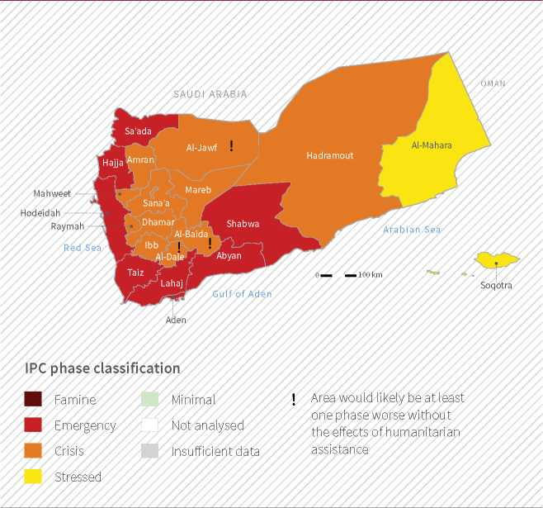

Source: Yemen IPC Technical Working Group, March 2017

Justification

The provision of food and cash assistance is essential yet unsustainable and will, in the long run, lead to food-aid dependency and the erosion of the population’s coping mechanisms. Rainfed and irrigated crops, livestock and fisheries remain the main source of livelihoods for the bulk of Yemenis, especially for those living in rural and peri-urban areas. These must therefore be an integral part of the emergency relief and early recovery response to prevent Yemen’s dire food security situation from worsening. Investing in agricultural livelihood interventions will help food insecure households to produce much-needed and life-saving food and reduce their dependency on food assistance and food imports. Given that vulnerable farming and fishing households lack physical and economic access to inputs (because of insecurity, damaged infrastructure and greatly reduced purchasing power) and the disruption of markets in many areas, any emergency or recovery assistance needs to include support to supply and market chains.

Agriculture remains the main source of livelihoods for the bulk of Yemenis living in rural and peri-urban areas

The integration of longer-term capacity development, climate-smart agriculture (CSA), natural resources management (NRM) and value chain development into different types of interventions will reinforce the livelihood restoration and resilience of earlier short-term responses and lead to a sustainable recovery of Yemen’s agriculture sector at all levels, such as household, community and institutional. Without longer-term scaling up, capacity development and climate change adaptation (CCA), FAO’s current support to the relief and protection of rural and peri-urban livelihoods of farm, pastoralist and fisher families will continue to depend on prolonged food and cash assistance in 2018 and beyond. Furthermore, this will reduce the tendency among vulnerable farmers, women and women-headed households in particular, to depend on income generated from the socially and environmentally damaging, but financially lucrative, production of *qat*.

Alignment and strategic fit

FAO’s Plan of Action will contribute to the following goals, policies, plans and programmes:

* National Fisheries Strategy (2012-2025), National Agriculture Sector Strategy (2012-2016) and National Water Sector Strategy and Investment Programme (2005-2009) - although out of date, are still regarded as current by the Government and will require updating in the future.
* United Nations Development Assistance Framework (2012-2015), extended to 2018 and in process of being extended to 2019, includes the priority actions for the adoption and resourcing of agriculture and fisheries sector strategies, implementation of rural income generating programmes, CCA and disaster risk reduction (DRR), and emergency food security, nutrition and resilience.
* FSAC’s operational response plan for the 2018 Humanitarian Response Plan (HRP) for Yemen. FSAC appealed for USD 1.27 billion in order to reach 8.8 million ofthe 11.3 million people in acute need of humanitarian assistance.
* FAO 2018 Emergency Livelihood Response Plan (ELRP), which has three key outcomes: (i) improved agricultural production and livelihoods security of the most vulnerable households through emergency provision of agricultural inputs, and protection and safeguarding of livestock; (ii) restored and diversified agricultural-based livelihoods and income-generating opportunities; and (iii) strengthened coordination in the fields of agriculture and food security for effective decision making.
* Global Sustainable Development Goal (SDG) 2, “End hunger, achieve food security and improved nutrition and promote sustainable agriculture”; while supporting SDG 1, “End poverty in all its forms everywhere; SDG 5, “Achieve gender equality and empower all women and girls; SDG 6, “Ensure availability and sustainable management of water and sanitation for all”; SDG 12, “Ensure sustainable consumption and production patterns; SDG 14, “Conserve and sustainably use the oceans, seas and marine resources for sustainable development; and SDG 15, “Protect, restore and promote the sustainable use of terrestrial ecosystems, sustainably manage forests, combat desertification, halt and reverse land degradation and halt biodiversity loss”.

Lessons learned

The prioritization and implementation modalities for the pillars and key intervention areas of the Plan builds on experiences and lessons learned from FAO’s investment and involvement in the following plans, frameworks, programmes and projects over the protracted conflict period:

* Annual UN HRPs (2013, 2014, 2015, 2016 and 2017).
* FAO 2013-2017 Country Programming Framework, which identified five priority areas: (i) policy development, strategic planning and strengthening of agricultural information systems; (ii) improved efficiency of the agri-food sector and enhanced agricultural and fishery production and productivity, food safety and food security and nutrition; (iii) development and conservation of natural resources and their sustainable management and efficient utilisation; (iv) value addition, agro-processing and marketing, and promoting the private sector’s role; and (v) sustainable livelihoods and enhanced food security and nutrition for the most vulnerable farming, fishing and rural communities and improved DRR and emergency management.
* FAO Plan of Action - Towards resilient and sustainable livelihoods for agriculture and food security and nutrition (2014-2018).
* FAO 2017 ELRP.
* FAO’s ongoing and recently completed emergency relief, early recovery and agricultural development projects. Since 2013, FAO has implemented more than 30 projects benefiting approximately 2.5 million vulnerable people.
* Since 2014, FAO Yemen - in collaboration with key national and governorate-level partners - has been implementing a programme to strengthen food security and nutrition information systems (FSISs) that ensure evidence-based information is provided for analysis and decision-making purposes. The programme has registered notable impact in promoting responsibility on the part of government staff in creating a sense of ownership of results and activities that will support planning and implementation ofthis Plan.

Stakeholder engagement

FAO has consulted and engaged with relevant stakeholders at all levels throughout 2017 and early 2018 in formulation ofthe Plan:

* Rural and peri-urban communities - through focus group meetings and the implementation of participatory farmer field schools (FFSs), livestock farmer field schools (LFFSs) and fisher field schools (FsFSs) under ELRPs and associated projects.
* Governorate and district authorities, and UN and Non-governmental Organization (NGO) implementation teams through consultative meetings and participation in the country’s six humanitarian hubs (Aden, Al Hudaydah, Ibb, Mukalla, Sa’ada and Sana’a).
* Ministry of Planning and International Cooperation (MoPIC), Ministry of Agriculture and Irrigation (MAI), Ministry of Fish Wealth (MFW) and Ministry of Water and Environment (MWE), UN agencies and NGOs at the national level through continued dialogue, consultative meetings and workshops and participation in FSAC.
* Resource partners - through continued dialogue and consultative meetings.

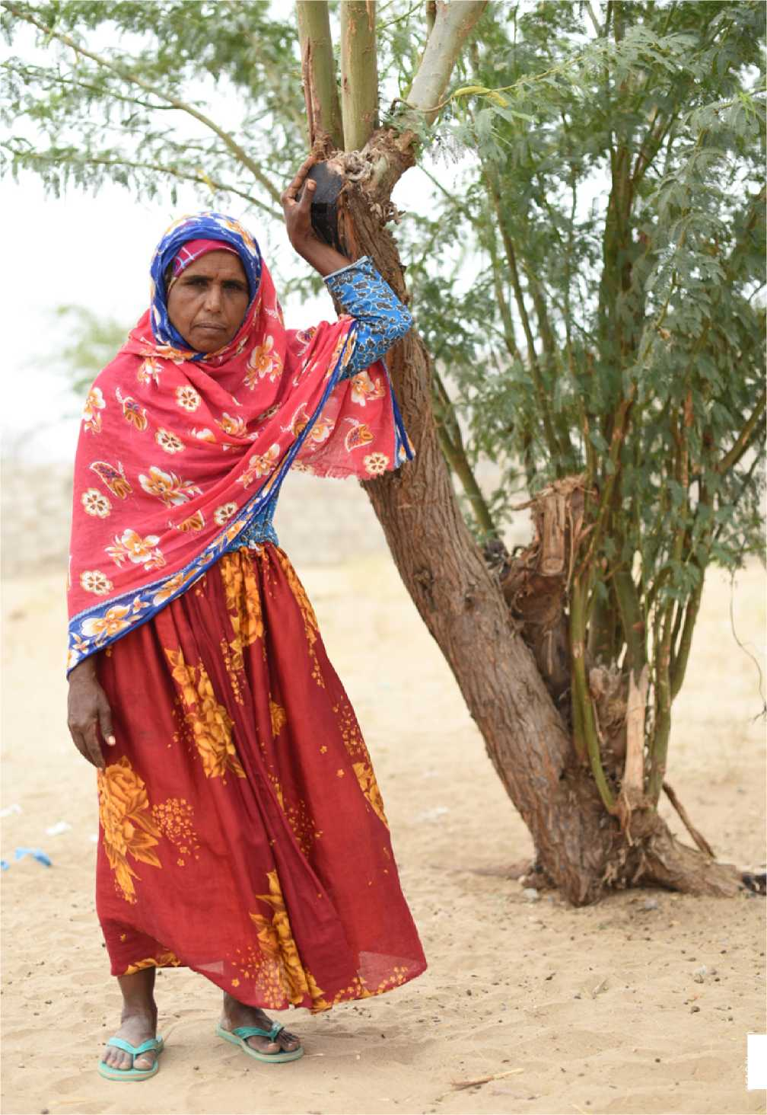

©FAO/Yemen

Framework

Goal and objectives

The overall goal of FAO’s three-year Plan of Action is to make a significant contribution towards improving food security and nutrition and strengthening the resilience of vulnerable rural and peri-urban households[8] while restoring the agriculture sector[9] of the country.

The objectives of the Plan of Action are to:

* Address the immediate food security, nutrition and income generating needs of all affected rural and peri-urban households (including IDPs, refugees, migrants and women-headed households) in Yemen.
* Ensure that vulnerable rural and peri-urban communities are assisted with appropriate agricultural livelihood restoration and resilience strengthening interventions, taking into account the specific needs and priorities of women and girls.
* Restore and reinforce the capacity of national, governorate and district­level and government and non-governmental agricultural, livestock and fisheries service providers to support agricultural livelihood restoration and resilience strengthening interventions.

Strategic approach

FAO’s Plan of Action will be implemented through a flexible twin-track approach that can be tailored to its target areas for different types of intervention dependent on the local conflict dynamics and changing circumstances of the country over the next three years. The strategic approach will therefore focus on:

* Scaling up current emergency food security, nutrition and cropping, pastoral and fisheries-based livelihood responses across all famine-risk districts.
* Investing in capacity development and improved agricultural service delivery interventions at the governorate, district and community levels in order to recover and improve crop, livestock and fisheries productivity on a sustainable basis, as well as promoting sustainable NRM, taking into account the specific needs and priorities of women and girls.
* Strengthening sectoral planning, programming, implementation and coordination mechanisms for the efficient utilisation of resources along and across both tracks, and a more cost-effective impact on longer- term household and community resilience.

The twin-track approach comprises interlocking related but distinct elements that will enhance the resilience and sustainability of both emergency relief and early recovery levels of response (e.g. agricultural, livestock and fisheries extension services, seed supply systems, animal vaccination campaigns and value chain development). In this context,

the Plan of Action prioritises and promotes inter-related and mutually supporting short- and longer-term climate-smart interventions at all levels (household, community and institutional), that would ultimately contribute to overcoming the underlying causes of rural and peri-urban vulnerability and effects of climate change in Yemen, addressing the specific needs and priorities of women and girls.

Targeting criteria

FAO’s Plan of Action is founded on two levels of targeting criteria.

Needs and vulnerability, emphasising the following geographic and human dimensions to prioritise target areas and groups for interventions under Pillar 1, such as:

* Governorates with the highest levels of food insecurity (i.e. Integrated Food Security Phase Classification [IPC] Phases 3, 4 and 5) and districts with the highest famine-risk (current number at 107 districts out of a total of 333); areas which have a high risk or are vulnerable to sliding into food insecurity without food production and livelihood support.
* Vulnerable rural and peri-urban households - especially those headed by women and/or people with a disability - suffering acute and severe food insecurity and malnutrition (including malnourished children, pregnant women and nursing mothers), loss of their productive assets and/or lacking access to land and water and a stable source of income, and areas with gaps in emergency relief and livelihood recovery responses.

Potential leveraging impact through capacity development of relevant stakeholder institutions (government, NGOs and private sector planning agencies, service providers and inspectorates concerned with strengthening the resilience of agricultural livelihoods and supporting the recovery of the agriculture sector in Yemen) - emphasising the following technical- and context-related dimensions:

* Suitability of target districts and communities according to the technical requirements of interventions for cost-effective restoration and resilience strengthening of agricultural livelihoods (e.g. rainfed and irrigated cropping, animal production and health) and fisheries-based interventions will be implemented in the appropriate agro-ecological zones. Cash-based and income-generation-based interventions will be implemented in areas where markets are functioning, and livelihood recovery and sustainable NRM interventions will be implemented in areas where conflict dynamics show relative stability.
* The role of target institutions in planning, programming, coordinating and implementing interventions for emergency relief and restoring the agriculture sector through promotion of project cycle management, CSA and value chain development (e.g. agricultural, livestock and fisheries extension services, plant protection services, veterinarians and community animal health services, agricultural input suppliers, agri-food processors, market traders, and agricultural inputs quality control and food safety inspection services).

The Plan of Action aims to reach an estimated 1.3 million vulnerable rural and peri-urban households (9.66 million people) throughout its three- year duration. It is further estimated that: 30 percent of the 1.3 million direct beneficiaries will be female homestead farmers, livestock owners, agri-food processors, etc.; 55 percent will be male farmers, pastoralists, fishers, etc.; and 15 percent will be youth (targeting especially agri-food processing and marketing and micro and small enterprise development initiatives). The Plan of Action will further strengthen the capacity of an indeterminate number of government, NGO and private sector decision makers, managers, supervisors, inspectors, technicians, extensionists and veterinarians for implementation of restored and improved seed production and supply systems, agricultural, livestock and fisheries extension services, veterinary and animal health services, public-private community partnerships/value chains, inspection services for the quality control and safety of imported agricultural inputs and exported foodstuffs.

Gender equality

FAO is committed to mainstreaming gender in all of its work and implements targeted actions to strengthen the livelihood resilience of women, men, girls and boys in crisis situations

FAO is committed to mainstreaming gender in all of its work, including in strategies, action plans, programmes and projects - in line with its Gender Equality Policy (2012) and supported by its Regional Gender Strategy and Action Plan for the Near East and North Africa (2016-2020). In conflict situations such as Yemen, the importance of gender mainstreaming cannot be neglected or ignored. Women, men, girls and boys are affected differently and face different risks, which have a bearing on their capacity to access food and agricultural livelihood opportunities.

Identification of needs, planning, targeting and implementation of interventions will take into consideration vulnerable groups’ needs. It is therefore essential to increase the importance given to gender-based analysis in assessing needs and formulating emergency and restoration responses. In particular, it is necessary to identify specific needs and capacities with regard to women, men, girls and boys (as well as the elderly and/or people with a disability) in order to implement targeted action and strengthen their livelihood resilience in crisis situations.

Gender issues among host communities, IDPs, refugees, returnees and migrants should also be acknowledged, as a considerable number of vulnerable members belongto households headed bywomen, including widows, women abandoned by their husbands and those whose husbands are detained. In addition, the gender relations and roles within IDP, refugee, returnee and migrant families are changing with the new division of labour between men and women possibly challenging traditional views. In this context, a gender analysis will be carried out when launching the Plan of Action in order to assess the specific situation in which both men and women face and monitor progress towards addressing the existing gender inequalities in terms of access to productive resources, services and advisory services, and empowering vulnerable women and girls. A thorough gender analysis will be followed up throughout the

implementation of the Plan of Action to increase women’s and youths’ access to resources and services.

Conflict sensitivity and contribution to sustaining peace

FAO’s conflict-sensitive programming approach will be informed through regularly conflict analyses

Disenfranchisement of vulnerable populations caused by fragile peace agreements, ongoing protracted conflicts, social unrest, localized instability in isolated areas and struggles over control of natural resources is compounding poverty and food security and nutrition problems. The negative impacts of rebel groups, terrorist organizations and international criminality, as well as climate change, exacerbates underlying causes of conflict and hunger as the spectres of high profile events such as piracy attacks in the seas and drought stalk the region continually.

Investments in agriculture and creating viable jobs in the sector prior to the current crisis had indirect effects on controlling migration from rural to urban areas and contributed to social stability and local peace-building efforts. Investments prioritizing the creation of decent on- and off-farm income-generating opportunities (e.g. cash for work and small agri­business development) - if accompanied with stronger social protection systems and supporting youth entrepreneurship and employment - may help ease the long-term pressures that drive irregular migration to Gulf countries, support the peace-building process and build resilience.

As there is an array of Yemeni factions vying for control over territory, natural resources and/or populations, the context is highly fluid, necessitating conflict analysis and monitoring to inform strategic decisions for a response. The Yemen context requires an institutionalised understanding of the conflict dynamics so as to inform programme design, implementation, access and effective evaluation. FAO’s mandate, technical expertise, in-country experience and established networks provide the Organization with the important role of responding to the impacts of conflict and the drivers of conflict in both a programmatic and coordination role. In assuming this role, FAO is developing conflict-sensitive approaches and specific tools to be applied by partners to ensure that interventions do not contribute to a deterioration of the conflict and, where possible, positive transformations can be achieved within the area of intervention.

Although the number of factions in Yemen contribute to the complexity and fluidity of the context, localised interventions related to FAO’s mandate have the potential to reduce or mitigate the drivers of conflict and may contribute to sustainable peace through improved stakeholder engagement, social cohesion and co-management of shared resources. FAO’s conflict-sensitive programming approach will therefore be informed through regularly updated and comprehensive conflict analyses, with developed scenario planning informing the more strategic management decisions on targeting of interventions.

**6T I** usujsa

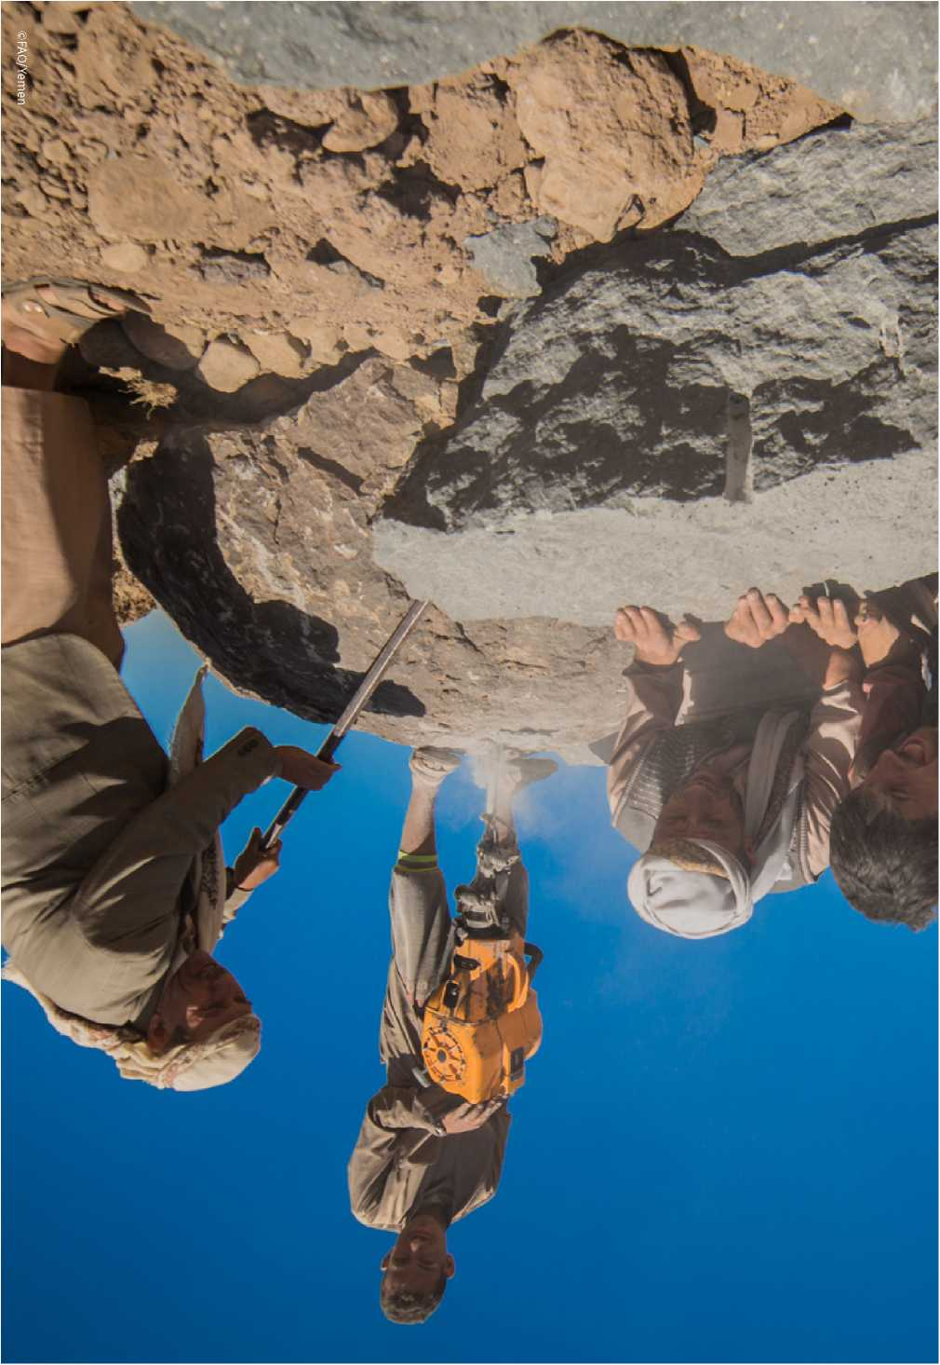

|  |  |
| --- | --- |
| Pillars and key intervention | FAO’s Plan of Action comprises three pillars, which mutually reinforce 21 short- and longer-term key intervention areas in support of safeguarding, protecting and restoring Yemen’s agriculture sector in target areas. |
| areas | * Pillar 1. Emergency support to the most vulnerable rural and peri-urban households (across famine-risk districts) * Pillar 2. Support to the sustainable restoration and diversification of agricultural livelihoods and agri-food systems (across districts where access is secured) * Pillar 3. Improved coordination of planning, programming and support for food security, nutrition and agricultural livelihoods   **Pillar 1**  Emergency support to the most vulnerable rural and peri-urban households (across famine-risk districts).  **Cost estimate: USD 150 006 000**  **To assist: 1 171 250 households**  FAO aims to scale up its current emergency response across all 107 famine­risk districts of Yemen to prevent the already severe levels of food insecurity and malnutrition from worsening. This will be achieved under annual programmes over a three-year period.  The key intervention areas are founded on and include the  Organization’s 2018 ELRP, i.e. FAO’s proposed contribution (of  USD 57.1 million) to FSAC’s operational response plan for the 2018 HRP.  The pillar comprises eight short-term key intervention areas to reach 1.17 million vulnerable rural and peri-urban households.  Pillar 1 contributes to FAO Strategic Objective 5 “Increase the resilience of livelihoods to threats and crises” and Regional Initiative “Building resilience for food security and nutrition in the Near East and North Africa”. |

Key intervention area 1.1

Cash-based transfers for the rehabilitation of on-farm and community­level rural infrastructure and plantations

Outputs

* Approximately 50 000 rural and peri-urban households benefiting from cash-based transfers.
* USD 17 million of funds distributed through cash for work, cash for food, cash for training and vouchers.
* Approximately 100 shallow wells, springs, ponds, rainwater harvesting structures (e.g. underground cisterns, open *wadi* pits and roof-top micro-irrigation), water diversions and controls (for spate irrigation), irrigation channels and retaining walls constructed/rehabilitated; and 1 250 ha of irrigation systems and terraces, *wadi* soil conservation and erosion control measures (e.g. check dikes and vegetative barriers and plantations) and community-based forest, woodlot and rangeland management measures constructed/rehabilitated and planted/ protected.

Activities

* Undertake needs assessments of damaged structures and beneficiary selection (with gender considerations) across short-listed districts.
* Prepare basic engineering designs, cost estimates and works schedules for the repair and rehabilitation of selected on-farm and community­level rural infrastructure.
* Implement and monitor works schedules for the rehabilitation of shallow wells, springs, ponds, underground cisterns, open *wadi* pits, roof-top micro-irrigation systems, water diversion and control structures, irrigation channels, retaining walls, check dikes, vegetative barriers and plantations.
* Train men, women and youth beneficiaries in artisanal work skills (e.g. building, carpentry, gabion weaving, pipe work and pump repairs).
* Train selected service providers and community leaders in the mechanisms of cash-based transfer systems adopted for implementing and monitoring the aforementioned activities.

to assist

**50 000 households**

Cost estimate

**o USD 17 884 000**

Duration

**3 years** (as part of annual humanitarian response plans)

Key intervention area 1.2

Increasing crop production through the provision of CSA agricultural kits

Outputs

* 200 000 farming families benefiting from increased climate-smart cereal production; and 175 000 homestead vegetable gardens established.
* 7 750 tonnes of quality cereal seeds distributed and 200 000 ha of land planted under climate-smart cereal production - over three years.
* Additional 250 000 tonnes of cereals harvested and an indeterminable amount of vegetables produced that will be available for local food consumption and improved nutrition.

Activities

* Undertake participatory needs assessments (disaggregated by sex and age) and beneficiary selection (with gender considerations) across short-listed districts.
* Prepare basic farm plans for selected beneficiaries (including lists of agricultural inputs required).
* Procure, deliver and distribute 375 000 climate-smart agricultural kits of quality seeds, fertilizers and appropriate farm tools for cereal and vegetable production - as prescribed by the aforementioned farm plans.
* Mobilize, implement and monitor men and women FFSs to prepare basic farm plans and to promote new and improved cereal and vegetable production and technologies and practices and improved household nutrition throughout one cropping season (Box 1).

**lit**

to assist

**375 000 households**

Cost estimate

**o USD 33 082 000**

Duration

**1 year** (as part of annual humanitarian response plans)

Key intervention area 1.3

Enhancing livestock protection and productivity through re-stocking and improved animal health and production

Outputs

* 68 750 livestock-dependent households (including pastoralists and agro-pastoralists) benefiting from increased poultry and livestock production.
* Between 20 and 25 percent increase in the production of animal products (e.g. meat, milk and eggs) that will be available for local food consumption and improved nutrition.

Activities

* Undertake participatory needs assessments (disaggregated by sex and age) and beneficiary selection (with gender considerations) across short-listed districts.
* Prepare basic farm plans for selected beneficiaries (including lists of livestock inputs required).
* Procure, deliver and distribute 8 750 tonnes of emergency animal feed supplies and 18 750 small ruminant and 25 000 poultry re-stocking packages - as prescribed by the aforementioned farm plans.
* Mobilize, implement and monitor men and women LFFSs to assist livestock producers and their families improve animal production and health and household nutrition (Box 1). LFFS facilitators will be assisted by female, male and youth community animal health workers (CAHWs) trained and equipped under key intervention area 1.7 in any given target area.

to assist

**68 750 households**

Cost estimate

**o USD 26 184 000**

Duration

**1 year** (as part of annual humanitarian response plans)

Key intervention area 1.4

Improving small-scale capture fisheries management through the provision of fishing equipment

Outputs

* 15 000 fisher families benefiting from increased capture fisheries production.
* Approximately 30 percent increase in the production of fresh fish that will be available for local food consumption and improved nutrition.

Activities

* Undertake participatory needs assessments (disaggregated by sex and age) and beneficiary selection (with gender considerations) across short-listed districts.
* Prepare basic artisanal fisheries plans for selected beneficiaries (including lists of fishery inputs required).
* Procure, deliver and distribute 15 000 sets of fishing equipment for boat repair, boat engines, fishing gear (e.g. nets and fish finders) and/or ice-boxes - as prescribed by the aforementioned artisanal fisheries plans. Mobilize, implement and monitor FsFSs to prepare basic artisanal fisheries plans and demonstrate and replicate new and improved capture fisheries production technologies and practices and improved household nutrition throughout one fishing season (Box 1).

to assist

**15 000 households**

Cost estimate

**USD 12 262 000**

Duration

**1 year** (as part of annual humanitarian response plans)

Key intervention area 1.5

Increasing income-generating opportunities through value addition and development of key value chains through the provision of high-value agricultural production, post-harvest and food processing inputs

Outputs

* 37 500 home-based income generating and employment creation ventures established; directly benefiting 15 000 men, 11 250 women and 11 250 youth.
* Approximately 30 percent increase in household income generated.

Activities

* Undertake value chain analyses and participatory household needs assessments (disaggregated by sex, age and other socio-economic characteristics) and beneficiary selection (with gender and age considerations) across short-listed districts.
* Prepare basic home-based agri-food business plans for selected beneficiaries (including lists of dairy production, beekeeping, agri-food processing and produce marketing equipment, tools, containers and materials required).
* Procure, deliver and distribute 37 500 household income-generating kits - as prescribed by the aforementioned home-based agri-food business plans.
* Mobilize, implement and monitor men, women and youth farmer/ fisher business schools (FBSs) to prepare basic home-based/agri- food business plans and to demonstrate and replicate new and improved greenhouse horticultural production, solar storage, solar- powered pumping, dairy production (including solar milk cooling), beekeeping, agri-food processing and produce marketing technologies and practices and improved household nutrition throughout one production cycle (Box 1).

to assist

**37 500 households**

Cost estimate

**USD 42 227 000**

Duration

**1 year** (as part of annual humanitarian response plans)

Key intervention area 1.6

Surveillance and control of transboundary plant pests and diseases to improve crop protection

Outputs

* The risk of invasive plant pest and diseases significantly reduced across all cropping areas of Yemen: the spread of transboundary plant pests and diseases such as Huanglongbing, *Xylella fastidiosa* and wheat rust and the threat of fall armyworm invading from Africa are effectively monitored and controlled.
* Capacities developed among government agencies and farmer groups for improved surveillance, inspection and control of transboundary plant pests and diseases.

Activities

* Improve and update monitoring and quarantine measures for transboundary plant pests and diseases and supply instruments, traps and tools needed for their detection and identification.
* Train 200 government plant protection inspectors, quarantine officers and technicians in order to improve survey, inspection and control through training of trainers.
* Implement pest and disease surveys and reporting through FFSs in order to improve effective data collection and decision making for control measures.
* Develop contingency plans for controlling transboundary pests and diseases, in particular fall armyworm.

Cost estimate

**o USD 4 000 000**

■>( Duration

**® 2 years**

Key intervention area 1.7

Surveillance and control of transboundary animal diseases for the safeguarding of productive livestock

Outputs

* Approximately 50 government and private sector veterinarians trained in the design, implementation and monitoring of transboundary animal diseases (TADs) surveillance systems, diagnosis techniques and animal vaccination campaigns.
* 625 female, male and youth CAHWs identified, trained and equipped to support livestock owners.
* 625 000 livestock owners benefiting from approximately 1 000 district­level vaccination campaigns (in particular *peste des petits ruminants* and sheep and goat pox).
* Life, health and production saved for 12.5 million cattle, sheep and goats.

Activities

* Strengthen the capacity of government and private sector veterinary services at the governorate and district levels to design, implement and monitor decentralised animal vaccination campaigns for the control of TADs.
* Further identify, train and equip female, male and youth CAHWs for the: surveillance and reporting of TAD outbreaks; supporting government and private sector veterinary services with animal vaccination campaigns; and assisting LFFS facilitators with the implementation of LFFSs for improved animal health and production under key intervention area 1.3.
* Procure, deliver and distribute quality animal vaccines, appropriate cold chain equipment and vaccination tools to effectively deliver the vaccination campaigns designed.

to assist

**625 000 households**

Cost estimate

**USD 11 367 000**

Duration

**3 years** (annual vaccination campaigns)

**Box 1. Farmer field school approach to participatory extension**

* Identify master trainers within the country and the Near East region and provide initial or refresher training in farmer field school (FFS) methodology as well as climate-smart agriculture, animal production and health, sustainable fisheries management and small agri-business development* The master trainers are selected from government and private sector agricultural support and agri-business service providers and made available to train and support facilitators of FFSs, livestock farmer field schools (LFFSs), fisher field schools (FsFSs) and farmer/ fisher business schools (FBSs).
* Prepare and disseminate quality educational and communication materials on new and improved crop, livestock and fisheries production and post-harvest management technologies and practices (including energy) to be tested and validated, and participatory extension methodologies to be used.
* Identify and train FFS, LFFS, FsFS and FBS facilitators. Facilitators are trained by master trainers in a more formal course setting, with exposure to field sites and participatory meetings, aimed at developing their facilitation and technical skills. Facilitators are selected from local government extension workers, NGO social mobilizers, community leaders and “lead” farmers/ pastoralists and agro-pastoralists/ fishers/agri-food processors from successfully completed FFSs, LFSs, FsFSs and FBSs.
* Mobilize new and existing groups of between 15 and 25 men and women farmers, pastoralists/agro-pastoralists, fisher and agri-food processors from the selected beneficiaries and implement and monitor FFSs, LFFSs, FsFSs and FBSs to: (i) prepare farm plans, artisanal fisheries plans and home- and group-based micro and small enterprise development plans; (ii) test, validate and replicate new and improved cereal and vegetable production, dairy, sheep, goat and poultry production, fisheries production, beekeeping, agri-food processing and produce marketing technologies and practices (including energy) respectively; and (iii) demonstrate improved household nutrition (e.g. diversified diets, food preparation and food storage) - all throughout one cropping season/ production cycle/fishing season.
* Participants implement their respective schools by meeting with their facilitators frequently throughout one cropping season/production cycle/ fishing season. The meetings are held in the farmers’, pastoralists’, agro­pastoralists’ and fishers’ own fields, pastures and landing sites to learn, test and adapt new concepts and promising technologies and practices for adoption and local use, and receive further information from visiting master trainers as needed.

* [http://www.fao.org/farmer-field- schools/expert-roster/en/](http://www.fao.org/farmer-field-schools/expert-roster/en/).

Key intervention area 1.8

Strengthening the capabilities and capacities of Yemen’s Desert Locust Management System to implement effective and efficient preventive control strategies

Outputs

* Cropping areas, food security and livelihoods of rural communities safeguarded from desert locust swarms.
* Between 50 000 and 100 000 ha of high-risk desert locust infestation controlled.
* Desert locusts prevented from swarming in Yemen and migrating to neighbouring countries.

Activities

* Rehabilitate and upgrade desert locust monitoring and control centres; and strengthen the capacity of 100 government subject matter specialists and technicians in the survey, control operations and health environment monitoring through on-the-job training.
* Mobilize, implement and monitor men and women FFSs to safely use pesticides and biopesticides in locust control operations throughout one cropping season.
* Procure, deliver and distribute necessary spraying equipment, pesticides and biopesticides, communication and mapping equipment and campaign equipment, materials and protective clothing to desert locust control centres and surveillance and spray campaign teams.
* Strengthen desert locust information networks for improved survey and control through effective use of satellite-dynamic greenness maps.
* Develop contingency plans for controlling desert locust swarms.

Cost estimate

**USD 3 000 000**

■p Duration

**s® 3 years**

**Pillar 2**

Support to the sustainable restoration and diversification of agricultural livelihoods and agri-food systems (across districts where access is secured).

**Cost estimate: USD 70 500 000**

**To assist: 135 200 households**

Under Pillar 2, FAO aims to support the Government and its development partners to restore and improve agricultural and fisheries production and productivity to their pre-crisis levels across all districts where access is assured for the Organization and its service providers.

The key intervention areas will demonstrate model climate-smart technologies and practices and capacity development measures for each agro-ecological zone found in Yemen that will support actions for sustainable use of limited water resources and degraded lands and sustain improved crop, livestock, fisheries and forestry productivity beyond the three-year timeframe of the Plan.

The pillar comprises nine longer-term key intervention areas indirectly targeting 135 200 food insecure and poor rural and peri-urban households.

Pillar 2 contributes to FAO Strategic Objective 2 “Increase and improve provision of goods and services from agriculture, forestry and fisheries in a sustainable manner”, Strategic Objective 3 “Reduce rural poverty” and Strategic Objective 4 “Enable more inclusive and efficient agricultural and food systems” as well as Regional Initiatives “Near East and North Africa’s water scarcity initiative” and “Small-scale family farming in the Near East and North Africa”.

Key intervention area 2.1

Assessing agricultural post-damage needs with gender considerations

Outputs

* Investment programmes and plans of action for restoration of the agriculture sector prepared and adopted by stakeholders

Activities

* Conduct detailed damage and loss assessments to the agriculture sector across 20 governorates (once access is secured); and report the findings and recommendations for medium-term restoration and long­term rehabilitation and development of the crops, livestock, fisheries and forestry subsectors and NRM.
* Formulate evidence-based national, governorate and district-level investment programmes and plans of action for agricultural and fisheries restoration, resilient livelihoods and economic diversification.
* Mobilize funding for the medium-term restoration of the agriculture sector in accessible conflict-affected districts.

Cost estimate  
**o USD 1 500 000**

Duration

**-© 3 years**

Key intervention area 2.2

Reinforcing critical government and public-private rural infrastructure and agricultural facilities

Outputs

* 50 government and public-private agricultural structures repaired or rehabilitated and functioning (e.g. agricultural service centres, diagnostic laboratories, veterinary clinics, irrigation systems and storage facilities).
* 5 000 ha of agricultural land restored and functioning to support agricultural production (e.g. rehabilitated terraces, water harvesting structures and irrigation systems) by 4 200 smallholder farmers.

Activities

* In line with the above-mentioned post-damage needs assessments, select the most cost-effective infrastructure for repair or rehabilitation in terms of impact on the locally affected rural and peri-urban households.
* Undertake designs and cost estimates, issue tenders and award contracts for the repair or rehabilitation of the selected rural infrastructure - while maximising the use of cash for work for semi­skilled and unskilled labour generated from local women, men and youth.
* Manage contracts for the repair or rehabilitation of the selected rural infrastructure - ensuring the use and on-the-job training of local semi­skilled and unskilled labour.
* Train government and private sector managers, supervisors, technicians and operators of the repaired and rehabilitated infrastructure in best practices for their operation, maintenance and knowledge management and transfer.

to assist

**4 200 households**

Cost estimate

**USD 10 000 000**

■p Duration

**-® 3 years**

Key intervention area 2.3

Supporting existing seed production institutions, establishing community-based seed production systems and promoting public­private-community partnerships for seed supply

Outputs

* A decentralised cereal seed production and supply system revitalised and functioning across accessible districts - founded on public-private­community partnerships (PPCPs).
* 15 000 farming families benefiting from quality cereal seeds.

Activities

* Undertake feasibility studies and prepare business plans for a decentralised cereal seed production and supply system.
* Devolve and strengthen the National Seed Council and General Seed Multiplication Corporation at the governorate level - ensuring full participation of relevant and willing private sector companies.
* Develop PPCPs to ensure the sustainable production, processing, certification and marketing of quality cereal seeds at the governorate, district and community levels - through recognised gender and value chain approaches.
* Implement men, women and youth FFS programmes to ensure that farmers’ groups have access and know how to plant and protect the quality cereal seeds - with short- and medium-term linkages to key intervention areas 1.2 and 2.5.

to assist

**15 000 households**

Cost estimate

**USD 3 500 000**

Duration

**s® 3 years**

Key intervention area 2.4

Strengthening of decentralised government, private sector and NGO agricultural extension, plant protection and animal production and health services.

Outputs

* Governorate, district and sub-district-level agricultural extension and veterinary/animal health services familiar with and able to promote current CSA through participatory extension approaches (e.g. FFSs, LFFSs and FsFSs).
* Approximately 1 000 government, private sector and NGO subject matter specialists and agricultural and livestock extension workers trained in CSA technologies and practices (Box 2) and participatory extension methodologies (e.g. FFSs, LFFSs, FsFSs and FBSs).

Activities

**Box 2. Climate-smart agriculture technologies and practices**

* Agro-forestry, conservation agriculture, soil and water conservation and integrated plant­soil nutrient management
* Water harvesting and on-farm water management
* Integrated pest and disease management
* On-farm animal fodder production, “cut and carry”/stall-feeding of livestock, animal feed blocks, bio-secure animal housing, pasture management, community-based range management and community animal health services
* Sustainable fisheries management
* Undertake institutional assessments of MAI, MFW and MWE, relevant private sector organizations/companies and NGOs operating in accessible governorates and districts with recommendations for capacity development of concerned agricultural support services.
* Develop and implement an in-service training programme for female and male governorate, district and sub-district-level staff of MAI, MFW and MWE and targeted private sector organizations/companies and NGOs in CSA and modern approaches to crop, livestock and fisheries production, NRM and participatory agricultural, livestock and fisheries extension methodologies.
* Monitor, follow-up and adapt training programmes to any changes of circumstance (including accessibility to target districts and sub­districts).
* Rationalise the use of pesticides and introduce innovative control methods (with best practices such as integrated pest and disease management) without the use of pesticides or by partial and optimal time for applications (through FFSs) - and so reducing crop residues and reinforcing food safety.

Cost estimate

**USD 3 000 000**

Duration

**3 years**

Key intervention area 2.5

Promoting sustainable water resources management systems, decentralised irrigation management schemes and CSA technologies and practices

Outputs

* Number of sub-basin water management committees established and functioning (and committed to conflict and gender-sensitive water resource management approaches).
* 150 farmers’ associations and WUAs strengthened or established and functioning (and committed to conflict and gender-sensitive land and water resources management approaches).
* Approximately 75 000 resource-poor farmers adopting and practising new and improved CSA technologies and practices (Box 2), including CSA-relevant machinery, implements, tools and inputs.

Activities

* Identify three accessible water basins and re-establish or establish and strengthen sub-basin water management committees for the sustainable utilisation of land and water resources.
* Conduct data collection, analyses, application and dissemination of information on water resources in order to assess the quantity and quality of water available to irrigated agriculture.
* Re-establish or establish and strengthen farmers’ associations and WUAs for the rehabilitation and operation and maintenance of their respective terrace and irrigation systems.
* Rehabilitate the concerned terrace and irrigation systems - maximising cash for work for farmers association and WUA members and their families (with short- and medium-term linkages to key intervention areas 1.1 and 2.2).
* Mobilize, implement and monitor men and women FFSs to prepare comprehensive farm plans and demonstrate and replicate new and improved CSA technologies and practices (Box 2) and improved household nutrition (Box 1) - throughout one cropping season (with short- and medium-term linkages to key intervention areas 1.2 and 2.4; and further linkages to supply and market chains developed under key intervention area 2.7).

to assist

**75 000 households**

Cost estimate

**USD 16 500 000**



Duration

**years**

Key intervention area 2.6

Promoting sustainable livestock feeding systems to reduce feed losses and the cost of animal feeding, improve nutritional and production efficiency and increase milk and meat productivity and household income generation

Output

* Approximately 25 000 resource-poor livestock owners adopting and practising efficient, affordable and sustainable livestock feeding systems.

Activities

* Mobilize, implement and monitor men, women and youth LFFSs to prepare comprehensive farm plans and demonstrate and replicate new and improved sustainable livestock feeding technologies and practices (Box 2) and improved household nutrition (Box 1) - throughout one production cycle (with short- and medium-term linkages to key intervention areas 1.2 and 2.4).
* Strengthen the capacity of government and private sector veterinary services and livestock extension services to support the expansion of male, female and youth CAHWs and LFFSs for improving livestock productivity through more balanced feed supplies.
* Develop PPCPs for the manufacture and marketing of animal feed blocks and concentrated animal feed produced from local resources.

to assist

**25 000 households**

Cost estimate

**o USD 6 000 000**



Key intervention area 2.7

Promoting improved post-harvest management (PHM) and value chain development approaches for sustainable small-scale family farming and micro and small agri-food enterprises

Outputs

* Approximately 10 000 rural and peri-urban families benefiting from increased income and/or employment opportunities through micro and small-scale agri-food enterprise development - for commodities such as fruits, vegetables, coffee, live animals, meat, dairy, poultry and honey. These are high-value products that also represent alternatives to *qat* production.
* 20 PPCPs established to develop supply and market chains to support all family farming and micro and small-enterprise development initiatives under FAO’s Plan of Action.

Activities

* Undertake gender and value chain analyses of selected agricultural commodities, with particular reference to post-harvest and energy losses and recommendations for improved PHM and added value at both the household and community levels.
* Undertake feasibility studies and prepare business development plans for each of the potential micro-enterprises (home-based family farms) and small enterprises (community-based producer marketing groups or farmers’ cooperative associations).
* Mobilize, implement and monitor men, women and youth FBSs to: (i) prepare agri-food business plans; (ii) demonstrate and replicate new and improved technologies in micro-irrigation/horticulture production, small ruminant, dairy and poultry/meat, milk and egg production, beekeeping and honey production and agri-food processing, packaging, storage and local transportation; (iii) develop market linkages; and (iv) learn and apply small agri-business knowledge and skills (Box 1) - throughout one production cycle (with short-term linkages to key intervention area 1.5).
* Establish PPCPs to develop: (i) supply chains for the provision of appropriate farm machinery, implements, tools and agricultural and livestock inputs (required of farm plans prepared under short­term Interventions 1.2 and 1.3 and medium-term key intervention areas 2.5 and 2.6) and appropriate PHM equipment, tools, containers and materials (required of short- and medium-term home and group- based agri-food business plans prepared under key intervention areas 1.5 and 2.7); and (ii) market chains for the sale of surplus crop and animal production and processed agri-food commodities.

to assist

**10 000 households**

Cost estimate

**USD 9 500 000**

iIbbI] Duration

**3 years**

Key intervention area 2.8

Assessing and upgrading the capacities of the MAI and MFW for quality control and food safety of agricultural, livestock and fisheries inputs and exports

Outputs

* Government regulatory and institutional capacity for food safety and agricultural input controls is made integral and strengthened.
* All border inspection points are functioning according to the World Trade Organization’s sanitary and phytosanitary and technical barriers to trade control systems.

Activities

* Undertake an institutional assessment of all food safety and agricultural input supply stakeholders, including a gap analysis for all necessary food safety and agricultural input functions currently performed during the protracted crisis - with recommendations for phased capacity development that accommodates the minimum sanitary and phytosanitary and technical barriers to trade control system requirements for an immediate start up.
* Rehabilitate and strengthen sanitary and phytosanitary diagnostic laboratories, testing and certification facilities and reporting systems at designated entry/export points.
* Train approximately 75 female and male managers, supervisors, inspectors and technicians of border control facilities in science-based risk analysis and assessment for the application and enforcement of sanitary and phytosanitary and technical barriers to trade measures.

*O*

*COSt* Cost estimate

**USD 13 million**

■JI Duration

**“® 3 years**

Key intervention area 2.9

Diversifying fisheries-based livelihoods in vulnerable coastal communities

Output

* Approximately 6 000 rural and peri-urban families benefiting from increased income and/or employment opportunities through the diversification of capture fisheries-based livelihoods.

Activities

* Undertake detailed livelihood assessments of vulnerable coastal communities and value chain analyses of commodities (including aquatic animals) produced in such agro-ecologies with recommendations for the diversification of capture fisheries-based livelihoods.
* Mobilize, implement and monitor men, women and youth FBSs to: (i) prepare artisanal fisheries business development plans (or other recommended diversified agri-business development plans); (ii) demonstrate and replicate new and improved technologies in aquatic animal production and fish processing, packaging, storage and local transportation (and other diversified agri-food commodities processed); (iii) develop market linkages; and (iv) learn and apply small agri-business knowledge and skills - throughout one production cycle (with short-term linkages to key intervention area 1.4).
* Train men, women and youth beneficiaries in artisanal work skills in support of fish and other agri-food processing ventures in coastal communities (e.g. carpentry, electrical and plumbing, solar energy, cold chains and local transportation).
* Establish PPCPs to develop: (i) supply chains for the provision of appropriate fishing gear, boat building/repair equipment, tools and materials, ice boxes and ice and processing equipment, tools and materials; and (ii) market chains for the sale of processed fish and other agri-food commodities.

to assist

**6 000 households**

Cost estimate

**o USD 7 500 000**

**iWf** Duration

**3 years**

**Pillar 3**

Improved coordination of planning, programming and support for food security, nutrition and agricultural livelihoods (national coverage)

**Cost estimate: USD 8 000 000**

Under Pillar 3, FAO aims to provide technical support to the Government and concerned UN agencies, multilateral and bilateral resource partners, NGOs, civil society organizations and private sector organizations to strengthen coordination capacities for the planning, programming, implementation, monitoring and evaluation of short-term emergency, medium-term recovery and long-term development actions within the agriculture sector. Based on the lesson learned, FAO will continue expanding and strengthening an integrated and inclusive FSIS by building the technical and institutional capacity of concerned national and governorate-level ministries, agencies and authorities in support of evidence-based decision making. This pillar comprises four medium-term capacity development intervention areas.

Pillar 3 contributes to FAO Strategic Objective 1 “Contribute to the eradication of hunger, food insecurity and malnutrition”, Strategic Objective 5 “Increase the resilience of livelihoods to threats and crises” and Regional Initiative “Building resilience for food security and nutrition in the Near East and North Africa”.

Key intervention area 3.1

Supporting MoPIC and relevant line ministries in the development of appropriate food security and agriculture networks

Output

* The Government has the capacity to coordinate food security and agricultural planning, investment programming and technical and organizational support at the highest government levels.

Activities

* Provide technical support to MoPIC, in collaboration with MAI, MFW and MWE, to develop and implement an appropriate networking mechanism for the organization of high-level dialogue to coordinate planning, investment programming and technical and organizational support for food security, nutrition and agriculture and fisheries­based livelihoods in Yemen - considering the scattered location of government authorities and their development partners across the country and the Near East region.
* Provide technical support to MoPIC, MAI, MFW and MWE, to review the outcomes of pre-crisis food security, nutrition and agricultural policies and strategies in light of the protracted crisis.
* Provide technical support to MoPIC, in collaboration with MAI, MFW and MWE, to develop and use strategic conflict/context analysis that informs country programming, provides scenarios for targeting, develops a template for regular conflict monitoring and builds the capacity of staff and partners for conflict-sensitive interventions.

Cost estimate

**o USD 1 500 000**

Duration

**3 years**

Key intervention area 3.2

Scaling up evidence-based food security and agriculture information and drought and famine early warning systems

Output

* A national information and early warning system on food security and agriculture and fisheries-based livelihoods is functioning effectively across all governorates.

Activities

* Restore and upgrade the cross-sectoral food security and nutrition institutional framework established with FAO support prior to the protracted crisis.
* Strengthen and expand the current food security information system supported by FAO to include all 22 governorates of the country - in support of timely decision making and response planning under key intervention area 3.1 - including capacities to undertake efficient and effective integrated food security phase classifications, to assess rural and peri-urban livelihoods and to provide famine early warning.
* Strengthen stakeholder capacities to ensure that data collected from district and governorate levels is enhanced and better coordinated in order to improve analysis and to better understand key food insecurity drivers; data collected and analysed will be disaggregated by sex, age and other socio-economic characteristics.
* Strengthen stakeholder capacities for developing agriculture-specific weather and climate information products, seasonal impact outlooks, pre-seasonal crop selection and drought early warning systems.
* Develop and disseminate information products that promote the utilisation of food security and agriculture information systems among line agencies and other stakeholders.

Cost estimate

**o USD 2 500 000**

[!■■!] Duration

**3 years**

Key intervention area 3.3

Establishing and strengthening food security, nutrition and agricultural livelihoods information management platforms at decentralised hub levels

Output

* Multi-stakeholder and inter-ministerial food security, nutrition and agriculture and fisheries-based livelihoods information management platforms established and functioning at regional/hub levels (coordinated by FAO).

Activities

* Assess the capacity of stakeholders at governorate and district levels to collect, analyse and report food security, nutrition and agriculture and fisheries-based livelihoods information; and design an inter-ministerial and multi-stakeholders’ consultative and decision-making platform to collate and respond to, for example integrated food security phase classifications, livelihood assessments and damage and needs assessments, at regional/hub levels.
* Establish and/or strengthen food security and agriculture and fisheries­based livelihoods information management and decision-making capacities at regional/hub levels with participation of all relevant government, NGO, civil society, community-based and private sector stakeholders.
* Increase awareness among local government authorities in food security, nutrition and agriculture and fisheries-based livelihoods information management, and train relevant stakeholders in disaggregated data collection, analysis, storage and reporting at the regional, governorate and district levels.

Cost estimate

**o USD 2 500 000**

»!■»!< Duration

**3 years**

Key intervention area 3.4: Strengthening the capacity of FSAC for the coordination, integration and advocacy of emergency and longer-term food security, nutrition and agriculture interventions

Output

* FSAC has the capacity to coordinate food security and agriculture and fisheries-based livelihoods actions for short-term emergency relief, medium-term recovery and long-term development interventions.

Activities

* Continue to lead and provide financial and technical support to FSAC for the coordination of short-term emergency interventions, such as those described under Pillar 1.
* Develop a framework for the planning, resource mobilization, implementation, coordination, monitoring and evaluation of medium- and long-term agriculture sector restoration and development interventions, such as those described under Pillar 2, with linkages established to the Government’s planning, investment programming and support networks developed under key intervention area 3.1.
* Establish and/or strengthen food security and agriculture and fisheries­based livelihoods information management and decision-making capacities at regional/hub levels with participation of all relevant government, NGO, civil society, community-based and private sector stakeholders.

Cost estimate  
**o USD 1 500 000**

Duration

**-® 3 years**

Cost estimate

The total cost of FAO’s Plan of Action is estimated at USD 228.5 million.

As mentioned, the first year of the Plan of Action incorporates

Table 1. Budget (USD million)

|  |  |  |  |  |
| --- | --- | --- | --- | --- |
| **Pillar** | **2018** | **2019** | **2020** | **Total** |
| Pillar 1. Emergency support to the most vulnerable rural and peri-urban households | 57.10 | 50.66 | 42.24 | **150.00** |
| Pillar 2. Support for the sustainable restoration and diversification |  | | | |
| of agricultural livelihoods and agri-food systems | 11.75 | 23.50 | 35.25 | **70.50** |
| Pillar 3. Improved coordination of planning, programming and |  | | | |
| support for food security, nutrition and agricultural livelihoods | 2.67 | 2.67 | 2.67 | **8.00** |
| **Total** | **72.52** | **76.83** | **80.16** | **228.50** |

FAO’s 2018 ELRP, costed at USD 57.1 million - targeting 818 500 households (5.7 million people) across 16 of the country’s 22 governorates. As the emergency support of Pillar 1 is scaled up, it is anticipated that the number of targeted households (and respective annual budgets) per year will decrease as more and more districts are covered. At the same time, FAO will increase and dovetail its longer-term livelihood restoration efforts (and respective annual budgets for capacity development, service delivery, etc.) of Pillar 2, whereby many of the beneficiaries will be the same as those benefiting from Pillar 1, but through more indirect activities.

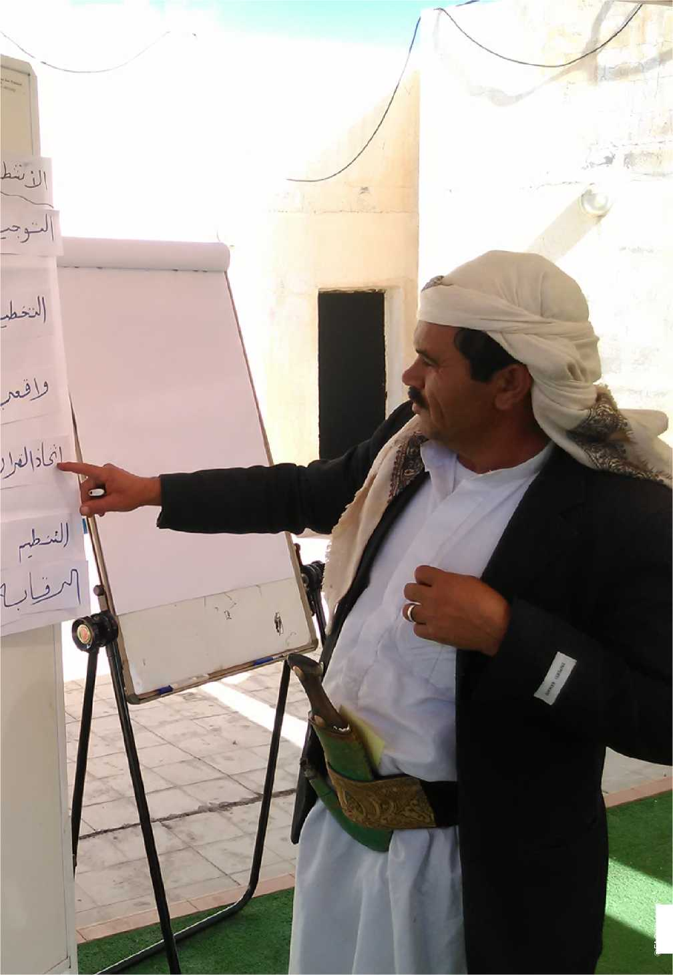

©FAO/Yemen

|  |  |
| --- | --- |
| FAO’s | Mandate to act |
| comparative advantage | The comparative advantages of FAO are derived from its mandate as a lead international agency for food security and agricultural development. FAO has therefore been a key actor in the whole process leading to the formulation of the 2030 Agenda for SDGs. In this context, FAO’s five Strategic Objectives are aligned to contribute to various SDGs:   * Contribute to the eradication of hunger, food insecurity and malnutrition. * Increase and improve provision of goods and services from agriculture, forestry and fisheries in a sustainable manner. * Reduce rural poverty. * Enable more inclusive and efficient agricultural and food systems. * Increase the resilience of livelihoods to threats and crises.   Moreover, FAO plays a crucial role in monitoring SDGs and is the custodian for 21 SDG indicators across six SDGs (2, 5, 12, 14 and 15 - Section 2.5) and a contributing agency for four more10. As well as strengthening statistical measures for food security and agriculture, FAO is further crafting indicators for NRM across multiple SDGs.  FAO’s position as a specialized UN agency which can act as a neutral broker for the Government and its development partners in difficult and complex issues related especially to policies, institutions and legal and regulatory reforms makes the Organization the ideal partner for implementing food security and nutrition and resilient agricultural livelihoods interventions that have a food and agriculture focus and benefit refugees, IDPs, migrants and remaining populations of rural and peri-urban communities in an integrated manner.  Capacity to act  FAO has a very high level of technical knowledge and experience of agriculture, food security and nutrition, especially for international standards and best practices for livelihood recovery and resilience, agricultural and rural development and agricultural CCA. FAO’s technical expertise and administrative support capacity are located at its headquarters in Rome, Italy and throughout its decentralized network of regional, sub-regional and country offices for the Near East and North Africa, the Gulf Cooperation Council member states and Yemen - all of which maintain strong links to the governments of member nations. Furthermore, FAO headquarters’ various technical services maintain several information systems with a large database on food security and nutrition, livelihood resilience, CSA, agricultural-, pastoral- and fisheries­based income generating and employment creation approaches, systems, technologies and practices and food safety and quality control. Best  10 The 17 global sustainable development goals have a total of 230 indicators. |

practices and lessons learned from similar programmes and projects in the field conducted by FAO and by others are also utilized by such networks. Finally, FAO offers a comparative advantage for creating synergies with other development partners’ programmes and projects of relevance in Yemen, especially through its co-leadership of FSAC.

Within the region, FAO supports 19 member states to achieve a sustainable food security for all, and help vulnerable communities and households to cope with and recover from shocks and crises by addressing three vital challenges: (i) water scarcity; (ii) fragile resilience; and (iii) the intertwined constraints that are impeding the productivity, profitability and contribution of small-scale family farming to economic growth. FAO delivers its work on these strategic priorities through three Regional Initiatives: (i) water scarcity; (ii) building resilience for food security and nutrition; and (iii) small-scale family farming[10]. Delivery managers at the FAO Regional Office for the Near East and North Africa (RNE), technically supported by networks of specialists based in FAO headquarters and offices within the region, coordinate the Regional Initiatives.

FAO declared the situation in Yemen as a Level 3 emergency in July 2015. Declaration of Level 3 emergency is normally undertaken in consultation with the Inter-Agency Standing Committee - a forum of key UN and non­UN humanitarian partners. Principles for declaring a Level 3 emergency are based on an analysis of scale, complexity, urgency, capacity and reputational risk of the crisis. Since the declaration, FAO Yemen has benefitted from fast-track procedures put in place by the Organization to facilitate programme and project development, resource mobilization, recruitment, procurement, operations and administrative support. In addition, focused and strategic coordination meetings are conducted on a weekly basis to discuss issues related to programme and project development, and address operational and administrative needs and bottlenecks.

The FAO Corporate Framework to support sustainable peace in the context of 2030 Agenda, approved in 2017, aims to transform the Organization’s engagements in conflict-affected situations into deliberately focused, strategic, and evidence-based approaches that support contributions to sustainable peace. Among other priorities, the Framework identifies the need to systematically undertake conflict-risk analyses, mainstream conflict-sensitive approaches and develop methodologies for conflict­sensitive programming.

In 2018, through the Strategic Programme - Resilience, FAO will build the capacity of selected country office staff, while developing tools and methodologies to assist the Organization in improving its programming in conflict-affected contexts. The process includes intensive support to a limited number of focus countries in order to test the tools and

methodologies. Given the importance of this work in the region and FAO’s Regional Initiative on “Building resilience for food security and nutrition in the Near East and North Africa”, Yemen has been selected as a pilot country. In this context RNE will organize a regional training on conflict­sensitive programming for Iraq, Libya, Sudan, Syria, West Bank and Gaza Strip and Yemen in mid-2018, followed by dedicated support to interested countries to build capacities and undertake conflict analyses to inform programming, according to available resources.

Position to act

FAO has been present in Yemen since 1974 and a FSAC co-lead since 2012. The Organization stepped up its activities from 2013 onwards with a focus on rural livelihood protection and restoration in partnership with relevant government line ministries (MoPIC, MAI, MFW and MWE), the Social Fund for Development and the Agriculture and Fisheries Cooperatives Unions and concerned UN agencies, in particular the International Labour Organization (ILO), United Nations Office for the Coordination of Humanitarian Affairs (OCHA), United Nations Development Programme (UNDP), United Nations Children Fund (UNICEF) and the World Food Programme (WFP), NGOs (e.g. Yemen Family Care Association, Yemeni Women Union, National Foundation for Development and Humanitarian Response, Millennium Development Foundation and Sustainable Development Foundation), community-based organizations and the private sector through more than 30 projects with a total value in excess of USD 100 million.

FAO is using participatory approaches across all of its current interventions that ensure sustainability through close collaboration with its partners and beneficiaries by engaging men and women farmers, pastoralists and fishers in activities with substantial social and economic benefits through the establishment of village agricultural producer groups, FFSs, LFFSs and FsFSs, WUAs and specialised cooperatives. Value chain approaches further ensure the involvement and partnership of major stakeholders, including the private sector and other investors along concerned supply and market chains. FAO continuously assesses best practices from their past interventions and that of other agencies, in both Yemen and the region as a whole. In this context, FAO Yemen has established a national network enabling access to secure areas and direct implementation of food security and livelihoods-related programmes and projects that has recently attracted resource partners, such as the European Union, the United States Agency for International Development and the World Bank to the Organization’s effective organizational capacity.

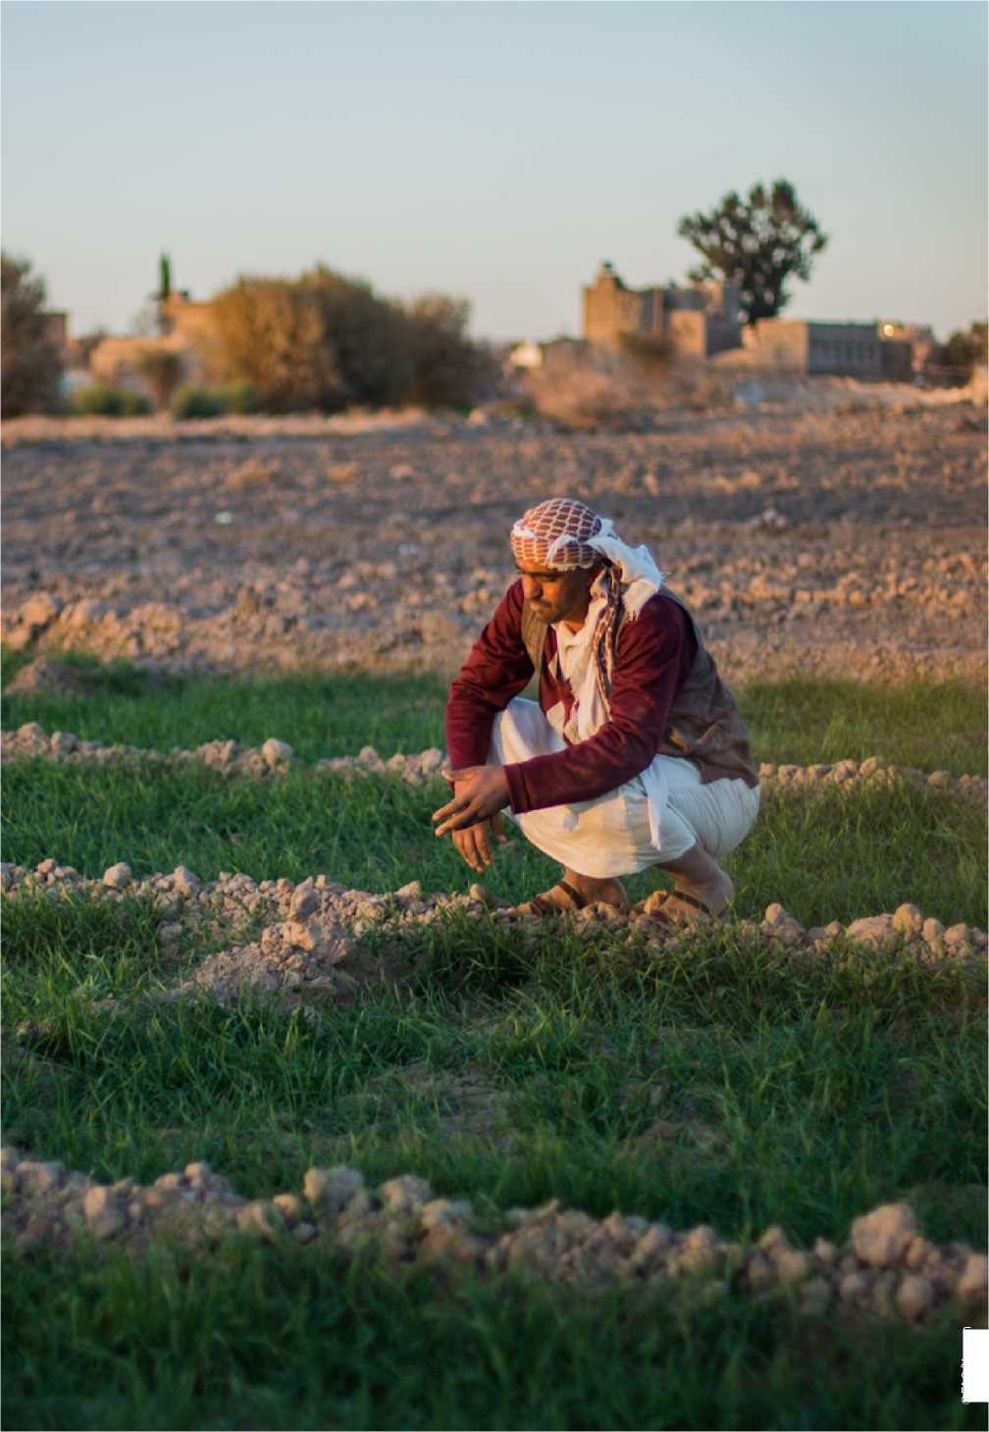

©FAO/Yemen

Implementation arrangements

Institutional framework

FAO will implement the Plan of Action’s key interventions in partnership with relevant government ministries, UN agencies and non-governmental service providers. In this context, the FAO Representative in Yemen oversees the programmes and projects funded under this Plan of Action and is responsible for general administration and financial supervision of funds provided by the concerned resource partners. Project planning will be conducted in close collaboration with the Yemeni authorities in order to facilitate clearances for the movement of FAO personnel and service providers to and from locations where interventions will be implemented.

FAO’s programming, project management, operations, administration and finance units are located in Sana’a. FAO is currently expanding its national and international technical and operational staffing capacities in order to effectively plan, implement, monitor and coordinate its increasingly devolved activities. FAO also plays an active role in six of the country’s regional humanitarian hubs, i.e. Aden, Al Hudaydah, Ibb, Mukalla, Sa’ada and Sana’a. These have been reinforced through the establishment of local coordination structures (governorate focal units or district committees) at both governorate and district levels for the purpose of further engaging, sharing and facilitating the planning, implementation and monitoring of FAO interventions and those of the Organization’s partners.

Since 2014, the FAO implemented FSIS programme enhanced the technical capacity of government and non-governmental partners in the collection, measurement, analysis and communication of food security and nutrition data. To date, FSIS governorate focal units, led by MoPIC, have been established in 13 governorates to facilitate and maintain agricultural information systems through data collection and sharing of food security and marketing information at governorate and district levels. It is anticipated that governorate focal units will be established in all 22 governorates with the support of interventions funded under the Plan of Action’s key intervention areas. FAO will therefore continue strengthening and expanding its technical support to FSIS programme in all governorates under the partnership and leadership of the national and governorate-level structures wherever possible with the necessary capacity development interventions.

FAO Yemen continuously receives technical and operational support from RNE and headquarters, where technical units and multi-disciplinary task forces provide constant technical oversight during the formulation, resource mobilization, implementation and evaluation of projects. FAO lead technical officers have daily interactions with the team in Sana’a, six regional hubs and at the field level, and are able to provide technical support services through the deployment of field missions to Yemen and project sites when required.

Coordination

Coordination of interventions implemented under the Plan of Action will be undertaken within the framework of FSAC coordination arrangements by FAO and its co-lead WFP. The rationale of the cluster system is to bring together all stakeholders involved in a specific thematic area with the aim of improving predictability, leadership and accountability in humanitarian activities. In a complex, Level 3 humanitarian operation of the magnitude experienced in Yemen, coordination is absolutely critical and essential, therefore FAO and WFP continued support to FSAC is vital.

The FSAC is currently composed of 75 partners drawn from relevant government institutions (e.g. the Food Security Technical Secretariat of MoPIC, MAI, the Social Welfare Fund and the Social Fund for Development), international and national NGOs, UN and related agencies, the International Red Cross/Red Crescent Movement, humanitarian resource partners and other development partners, and community-based organizations. FSAC partners have welcomed, and are committed to, the FAO initiative to prepare a three-year Plan of Action.

For the past three years, FSAC provided stable and predictable leadership to all humanitarian agencies operating in the agriculture sector of Yemen. The Cluster has provided an action-oriented forum for bringing together national and international humanitarian partners to improve the timeliness and impact of humanitarian assistance on the lives of the crisis-affected population in Yemen. In particular, FSAC aims to ensure coherent, coordinated and integrated humanitarian responses driven by the assessed food security and agriculture-based needs of the crisis-affected population. Maintaining regular cluster meetings at both the national level and the six regional humanitarian hubs through sub-clusters, has facilitated information sharing among partners and provided better coverage of response gaps thus avoiding duplication and/or overlap of assistance. FSAC aims to enable humanitarian actors to prioritise interventions, targets based on vulnerability and needs, adhere to minimum standards for assistance and use resources in a more efficient and effective way through better coordinated actions.

In collaboration with WFP and other partners, FAO aims to enhance FSAC’s coordination role for the integration and advocacy of longer- term food security, nutrition and agricultural recovery and development interventions rather than solely focusing on humanitarian assistance (i.e. key intervention area 3.4 “Strengthening the capacity of FSAC for the coordination, integration and advocacy of emergency and longer-term food security, nutrition and agriculture interventions”). In this respect, FSIS and FSAC will be supported by two other key intervention areas (3.2 “Scaling up evidence-based food security and agriculture information and drought/famine early warning systems” and 3.3 “Establishing and strengthening food security, nutrition and agricultural livelihoods information management platforms at decentralized hub levels”). Every effort will be made to ensure that the outputs of all four key intervention

areas under Pillar 3 are well coordinated and interlinked to ensure that reliable evidence-based data is readily available for multi-sectoral and integrated food security and agricultural decision making, planning and investment programming.

Strategic partnerships

It is acknowledged by all actors that no sectoral intervention alone would build resilience for sustainable livelihood recovery and rehabilitation which could only be achieved through complementary actions in relation with the respective mandates and comparative advantages that each actor brings in addressing food insecurity, malnutrition and poverty in Yemen from different angles. In this regard, it is worth noting that FAO’s Plan of Action, while directly targeting vulnerable farmers, pastoralists and fishers with short- and longer-term food security, nutrition and income generating interventions, would also be supporting the Government to recover its economy and stimulate agricultural growth through capacity development initiatives requiring the support of all partners. In this context, FAO, through its Plan of Action, would facilitate partnerships for food security and nutrition, agricultural development and NRM between:

* Government agencies (MoPIC, MAI, MFW and MWE) and local authorities (e.g. governorate and district councils).
* Civil society organizations (e.g. academic and research institutions, NGOs, community-based organizations and men and women farmers’/ pastoralists’/fishers’ organizations).
* The private sector (consultants, consultancy firms and veterinary doctors and input suppliers, traders, food processors, wholesalers, retailers and exporters of agri-food value chains).
* UN agencies (e.g. WFP for food security, ILO for “decent work”, OCHA for humanitarian relief, UNDP for poverty reduction and UNICEF, the World Organisation for Animal Health and World Health Organization for “One Health”).
* Development partners (bilateral and multilateral resource partners, international financing institutions and agriculture and rural development agencies/implementing partners).
* South-South Cooperation (deployment of short- and long-term specialists from countries of the Global South to facilitate the exchange and uptake of development solutions and promote platforms for knowledge networking to develop national and institutional capacities).

Monitoring and reporting

The day-to-day technical and financial monitoring of the implementation of activities under the 21 key intervention areas of the Plan of Action and the progress of FAO and service provider responsibilities will be a continuous process. FAO has established a technical and financial monitoring and reporting system that helps track all activities and outputs being implemented under ELRPs in the country and links them to FAO’s Corporate Strategic Framework (and its five Strategic Objectives and three Regional Initiatives). Upon the launch of the Plan of Action, the monitoring and reporting will be expanded to accommodate its three pillars and 21 key intervention areas, and some specific gender and conflict-sensitive indicators will be formulated to monitor and evaluate the gender and social stability-related results and impacts. At all levels, the FAO office in Yemen will monitor physical progress of component programme and project activities undertaken by FAO and its government and non-governmental service providers. The FAO Representative in Yemen, in turn, will keep the relevant government line ministries, resource partners, FSAC partners and concerned technical units at FAO headquarters and RNE continuously informed about activities and any delays or difficulties encountered during regular reporting mechanisms (e.g. monthly monitoring sheets and quarterly and annual progress reports), to ensure appropriate support or corrective measures can be adopted in a timely fashion.

Performance monitoring of interventions will pursue two objectives: (i) disaggregated information on progress made and give indications for sound technical and financial management of component programme and project activities; and (ii) practical experience on emergency relief, livelihood restoration and food security and agriculture coordination at local and national levels and in different rural settings. To ensure progressive learning and to draw lessons for the generalization of emergency relief and livelihood restoration, continued and coordinated monitoring and reporting is required. Contributing to these objectives is one of the activities of FAO’s support to FSAC for the “Strengthening of its mandate for the coordination, integration and advocacy of emergency and longer-term food security, nutrition and agriculture interventions” (key intervention area 3.4).

A common monitoring, performance assessment and reporting format would be conducted in accordance with established procedures of FAO and the Government, as well as participating resource partners. Logical framework matrices for each of the 21 key intervention areas will provide verifiable performance and impact indicators (disaggregated by sex, age and other socio-economic characteristics) for component programme and project implementation along with their corresponding means ofverification. These will form the basis on which the monitoring, performance assessment and reporting system will be built by FAO’s monitoring and evaluation unit. A key task of FAO is to assess the progress and impact and prepare findings to be shared at the national level helping the Government, FSAC and participating resource partners to demonstrate that commitments to resilient emergency relief and sustainable agricultural livelihood restoration are taken seriously.

To support financial monitoring and reporting obligations and the everyday implementation of the Plan of Action’s component programmes and projects and the corresponding use of resources, FAO will make use of

two tools available in its global Field Programme Management Information System (FPMIS): (i) automatic messages sent as reminders of delivery performance and reporting obligations and to flag certain conditions that may carry risks and/or require attention; and (ii) FPSN Monitoring Active Projects tool that allows the control of projects and portfolios against a broad range of conditions related to progress and performance. Furthermore, Budget Holder reports, available in the Business Intelligence Tool/Data Warehouse and also available in FPMIS, will be used to provide information about delivery against detailed budget lines and project expenditure.

Communication and outreach

One of the aims of FAO’s Plan of Action is to strengthen and support efforts in advocacy, awareness raising, knowledge management and communication, as well as other initiatives that raise awareness of emergency and recovery interventions targeting agricultural livelihoods. In particular, the Plan of Action’s communication and outreach activities will focus on the following areas:

* Increasing awareness, knowledge, understanding and visibility about the importance of emergency relief and livelihood restoration.
* Contributing to success stories from the field and highlighting emergency relief interventions and projects related to FAO’s work on livelihood restoration and sustainable agricultural development in Yemen.
* Interventions targeting agricultural livelihoods in the fight against hunger, malnutrition (with a focus on undernutrition and micro­nutrient deficiencies) and poverty (with a special emphasis on vulnerable women and youth).
* Advocate for greater commitment and financial investment in emergency relief and agricultural livelihood activities from government authorities at all levels, humanitarian partners and longer-term resource partners.
* Promote good practices, gender equality and women’s empowerment that can be scaled up and institutionalised in a national gender strategy for agriculture and food security in peaceful times.
* Contribute to FAO’s communication strategy towards ending hunger in FAO’s SDG 2 framework (Section 2.5).

To maximize reach, various groups will be targeted, including government authorities and line ministries, local institutions, service providers, humanitarian and development communities, local and international media, resource partners, and beneficiaries and beneficiary groups/ associations.

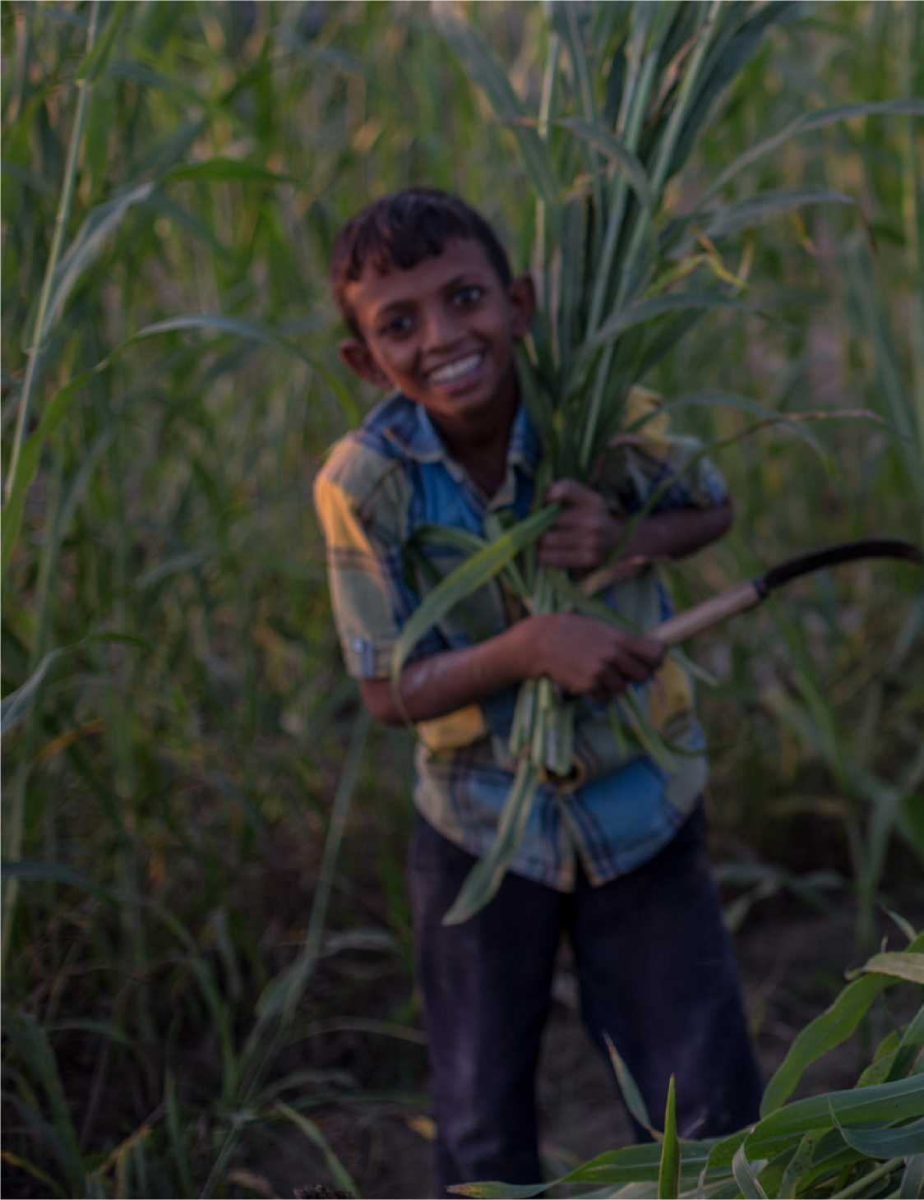

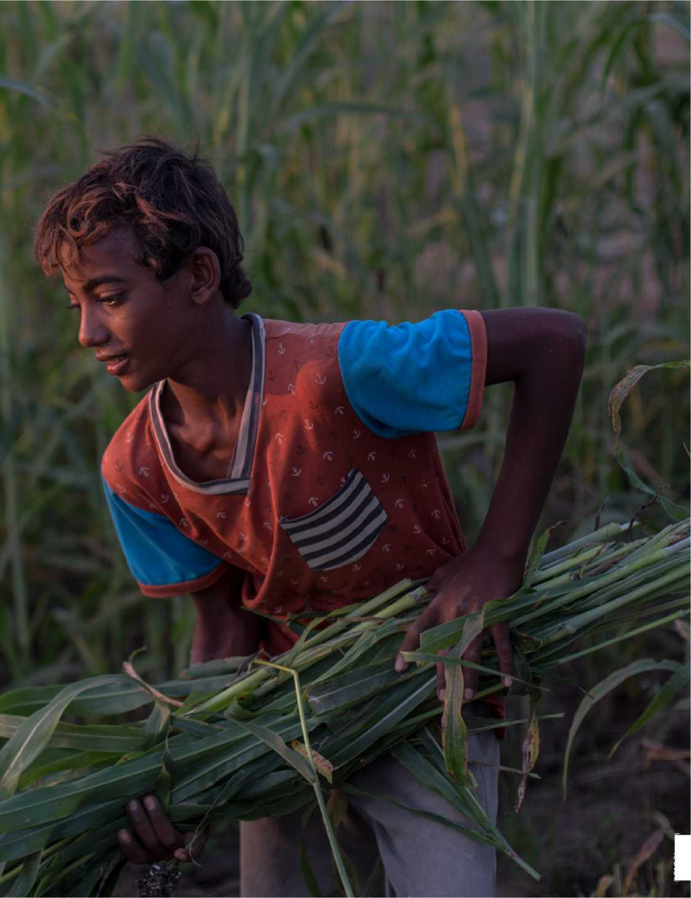

©FAO/Yemen

**[www.fao.org/emergencies](http://www.fao.org/emergencies) | [www.fao.org/resilience](http://www.fao.org/resilience)**

©FAO, 2018

03.18

**CONTACTS**

.org

Salah Hajj Hassan | FAO Representative | Sana’a, Yemen | [FAO-YE@fao.org](mailto:FAO-YE@fao.org)

Dominique Burgeon | Director, Emergency and Rehabilitation Division and Strategic Programme Leader - Resilience | Rome, Italy | TCE-Director@fao Food and Agriculture Organization of the United Nations

1. In this context, agricultural livelihoods refers to crop, livestock, fisheries and forestry-based livelihoods
2. United Nations Office for the Coordination of Humanitarian Affairs (OCHA). Humanitarian Update for Yemen, December 2017.
3. In this context, agricultural livelihoods refers to crop, livestock, fisheries and forestry-based livelihoods
4. A twin-track approach of short-term emergency relief interventions integrated with longer-term agricultural livelihood recovery interventions was recommended by the Food and Agriculture Organization of the United Nations (FAO)-led Integrated Food Security Phase Classification (IPC) of March 2017.
5. FAO defines resilience as: “The ability to prevent disasters and crises as well as to anticipate, absorb, accommodate or recover from them in a timely, efficient and sustainable manner. This includes protecting, restoring and improving livelihoods systems in the face of threats that impact agriculture, nutrition, food security and food safety”. In other words, resilience is the “ability of people, communities or systems that are confronted by disasters or crises to withstand damage and to recover rapidly”
6. Ministry of Planning and International Cooperation. Yemen Socioeconomic Update, January 2018.
7. Food Security and Agriculture Cluster (FSAC). Emergency food security and nutrition assessment, March 2017.
8. Including internally displaced people (IDPs) and returnees.
9. In this context, agriculture sector refers to crop, livestock, fisheries and forestry subsectors and NRM
10. <http://www.fao.org/neareast/en/>